Practical No.1

Aim: Write a program to implement Android activity Lifecycle.

MainActivity.java
package com.example. experiment2; import android.os.Bundle;
import android.util.Log;
import androidx.appcompat.app.AppCompatActivity; public class MainActivity extends AppCompatActivity {
@Override
protected void onCreate(Bundle savedInstanceState) { super.onCreate(savedInstanceState); setContentView(R.layout.activity_main); Log.d("Lifecycle", "Dattaram Kolte (Roll No: 97)"); Log.d("Lifecycle", "onCreate called"); }
@Override
protected void onStart() { super.onStart();
Log.d("Lifecycle", "onStart called"); } @Override
protected void onResume() { super.onResume();
Log.d("Lifecycle", "onResume called"); } @Override
protected void onPause() { super.onPause();
Log.d("Lifecycle", "onPause called"); } @Override
protected void onStop() { super.onStop();
Log.d("Lifecycle", "onStop called"); }

@Override
protected void onRestart() { super.onRestart();
Log.d("Lifecycle", "onRestart called"); } @Override
protected void onDestroy() { super.onDestroy();
Log.d("Lifecycle", "onDestroy called");

}
}

OUTPUT:
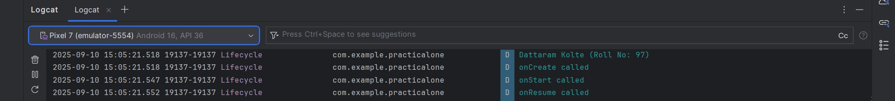

Practical No.2

Aim: Write a program to implement Basic Layout (Text Display).

MainActivity.java
package com.example.experiment2;

import androidx.appcompat.app.AppCompatActivity; import android.os.Bundle;
import android.view.View; import android.widget.Button; import android.widget.EditText; import android.widget.TextView;
public class MainActivity extends AppCompatActivity { private Button btn1;
private EditText ed1; private TextView txt1; @Override
protected void onCreate(Bundle savedInstanceState) { super.onCreate(savedInstanceState); setContentView(R.layout.activity_main);
btn1 = findViewById(R.id.button);
ed1 = findViewById(R.id.editTextTextPersonName); txt1 = findViewById(R.id.textview1); btn1.setOnClickListener(new View.OnClickListener() {
@Override
public void onClick(View view) {
String msg = ed1.getText().toString(); txt1.setText(msg.isEmpty() ? "Please enter text" : msg);
}
});
}
}

Activity_Main.xml
<?xml version="1.0" encoding="utf-8"?>
<androidx.constraintlayout.widget.ConstraintLayout xmlns:android="http://schemas.android.com/apk/res/android"

xmlns:app="http://schemas.android.com/apk/res-auto" xmlns:tools="http://schemas.android.com/tools" android:layout_width="match_parent" android:layout_height="match_parent" tools:context=".MainActivity">
<EditText android:id="@+id/editTextTextPersonName" android:layout_width="0dp" android:layout_height="wrap_content" android:ems="10" android:textAlignment="center" android:hint="Enter Your Name" android:inputType="textPersonName" app:layout_constraintEnd_toEndOf="parent" app:layout_constraintStart_toStartOf="parent" app:layout_constraintTop_toTopOf="parent"
app:layout_constraintBottom_toTopOf="@+id/button" app:layout_constraintHorizontal_bias="0.5" app:layout_constraintVertical_bias="0.3" />
<Button android:id="@+id/button"
android:layout_width="wrap_content" android:layout_height="wrap_content" android:text="Submit" app:layout_constraintEnd_toEndOf="parent" app:layout_constraintStart_toStartOf="parent" app:layout_constraintBottom_toBottomOf="parent"
app:layout_constraintTop_toBottomOf="@+id/editTextTextPersonName" app:layout_constraintHorizontal_bias="0.5" app:layout_constraintVertical_bias="0.5" />

<TextView
android:id="@+id/textview1" android:layout_width="wrap_content" android:layout_height="wrap_content" android:text="Result will appear here" app:layout_constraintTop_toBottomOf="@+id/button" app:layout_constraintBottom_toBottomOf="parent" app:layout_constraintStart_toStartOf="parent" app:layout_constraintEnd_toEndOf="parent" app:layout_constraintHorizontal_bias="0.5" app:layout_constraintVertical_bias="0.5" />
</androidx.constraintlayout.widget.ConstraintLayout>

OUTPUT:
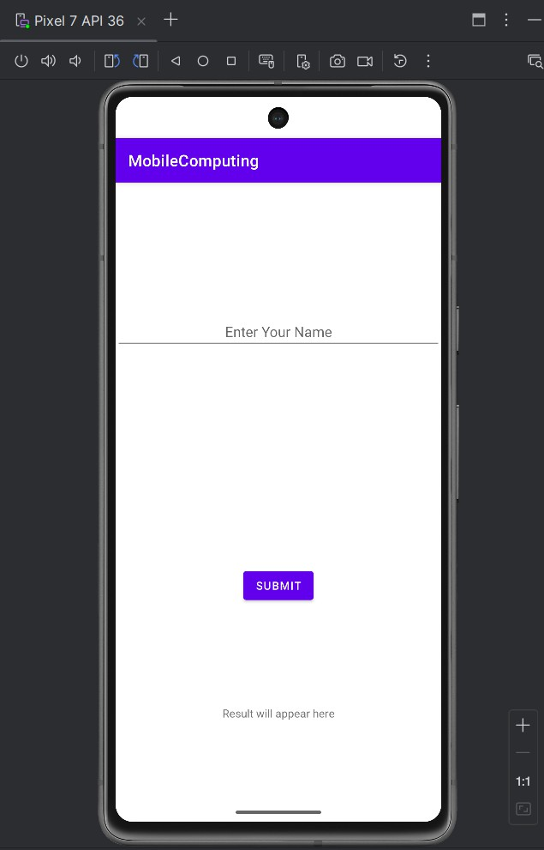
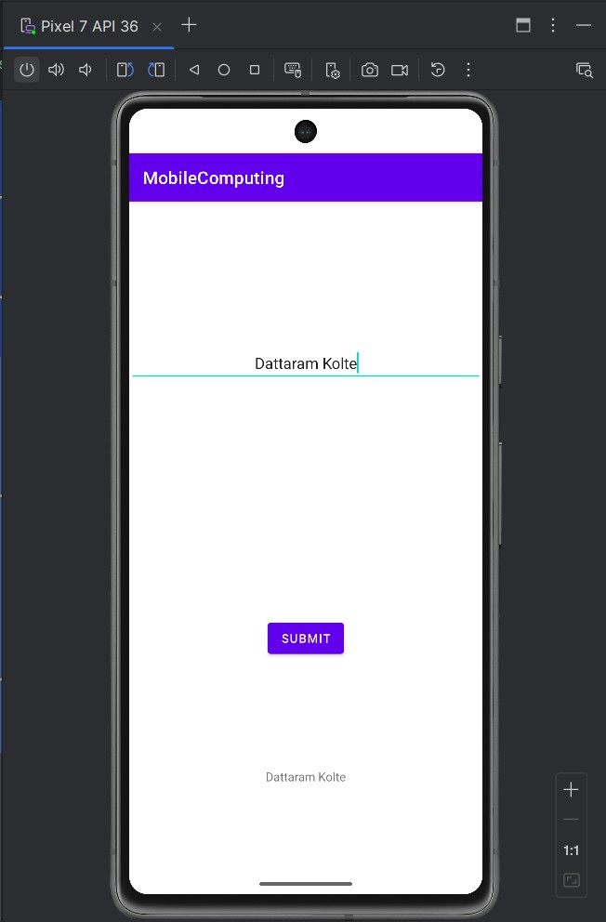

Practical No.3

Aim: Write a program to implement Toast.

MainActivity.java
package com.example.experiment3;
import androidx.appcompat.app.AppCompatActivity; import android.os.Bundle;
import android.view.View; import android.widget.Button; import android.widget.Toast;

public class MainActivity extends AppCompatActivity { private Button btn1;

@Override
protected void onCreate(Bundle savedInstanceState) { super.onCreate(savedInstanceState); setContentView(R.layout.activity_main);

// Initialize the button
btn1 = findViewById(R.id.button);

// Set OnClickListener to show the Toast message when clicked btn1.setOnClickListener(new View.OnClickListener() {
@Override
public void onClick(View view) {
// Show a Toast message
Toast.makeText(MainActivity.this, "Welcome Back, Dattaram !!!!", Toast.LENGTH_SHORT).show();
}
});
}
}

Activity_Main.xml
<?xml version="1.0" encoding="utf-8"?>
<androidx.constraintlayout.widget.ConstraintLayout xmlns:android="http://schemas.android.com/apk/res/android"
xmlns:app="http://schemas.android.com/apk/res-auto" xmlns:tools="http://schemas.android.com/tools" android:layout_width="match_parent" android:layout_height="match_parent" tools:context=".MainActivity">

<!-- Button to trigger the Toast -->
<Button android:id="@+id/button"
android:layout_width="wrap_content" android:layout_height="wrap_content" android:text="Show Toast" app:layout_constraintTop_toTopOf="parent" app:layout_constraintBottom_toBottomOf="parent" app:layout_constraintStart_toStartOf="parent" app:layout_constraintEnd_toEndOf="parent" app:layout_constraintHorizontal_bias="0.5" app:layout_constraintVertical_bias="0.5"/>

</androidx.constraintlayout.widget.ConstraintLayout>

OUTPUT:
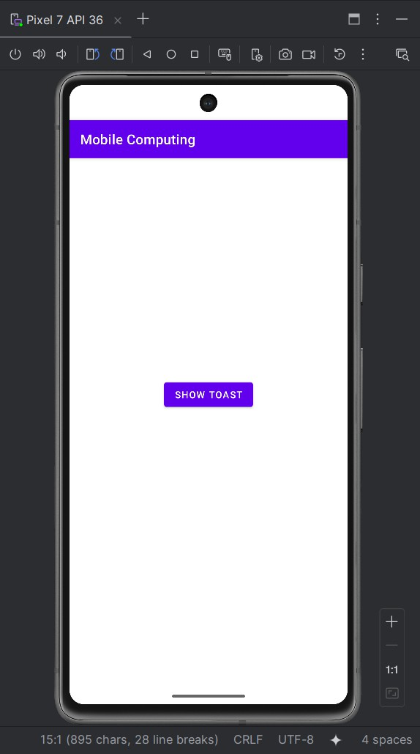
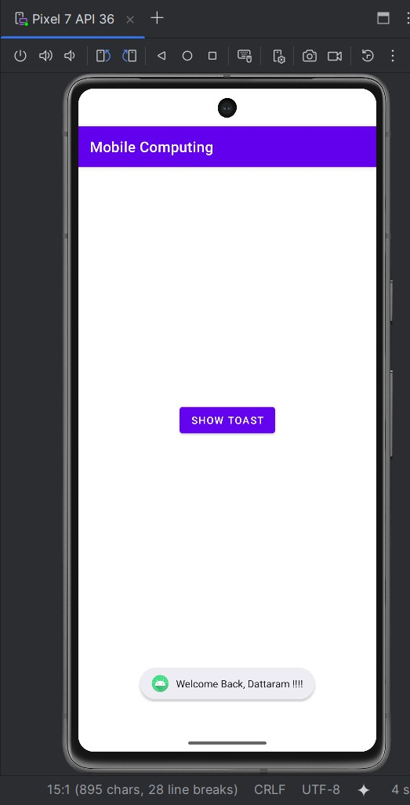

Practical No.4

Aim: Write a program to implement Simple Calculator.

MainActivity.java
package com.example.experiment4;

import androidx.appcompat.app.AppCompatActivity; import android.os.Bundle;
import android.widget.Button; import android.widget.EditText; import android.widget.TextView;

public class MainActivity extends AppCompatActivity { private EditText etNum1, etNum2;
private Button btnAdd, btnSubtract, btnMultiply, btnDivide; private TextView tvResult;

@Override
protected void onCreate(Bundle savedInstanceState) { super.onCreate(savedInstanceState); setContentView(R.layout.activity_main);

// Initialize views
etNum1 = findViewById(R.id.etNum1); etNum2 = findViewById(R.id.etNum2); btnAdd = findViewById(R.id.btnAdd); btnSubtract = findViewById(R.id.btnSubtract); btnMultiply = findViewById(R.id.btnMultiply); btnDivide = findViewById(R.id.btnDivide); tvResult = findViewById(R.id.tvResult);

// Button onClick listeners
btnAdd.setOnClickListener(v -> performOperation("add")); btnSubtract.setOnClickListener(v -> performOperation("subtract")); btnMultiply.setOnClickListener(v -> performOperation("multiply")); btnDivide.setOnClickListener(v -> performOperation("divide"));
}

private void performOperation(String operation) { try {
// Get numbers from EditTexts
double num1 = Double.parseDouble(etNum1.getText().toString()); double num2 = Double.parseDouble(etNum2.getText().toString()); double result = 0;

switch (operation) { case "add":
result = num1 + num2; break;
case "subtract":
result = num1 - num2; break;
case "multiply":
result = num1 * num2; break;
case "divide":
if (num2 != 0) {
result = num1 / num2;
} else {
tvResult.setText("Cannot divide by zero"); return;
}
break;
}

// Set the result in TextView tvResult.setText("Result: " + result);
} catch (NumberFormatException e) { tvResult.setText("Invalid input");
}
}
}

Activity_Main.java
<?xml version="1.0" encoding="utf-8"?>
<androidx.constraintlayout.widget.ConstraintLayout xmlns:android="http://schemas.android.com/apk/res/android"
xmlns:app="http://schemas.android.com/apk/res-auto" xmlns:tools="http://schemas.android.com/tools" android:layout_width="match_parent" android:layout_height="match_parent" android:background="#F0E8FF" tools:context=".MainActivity">

<EditText android:id="@+id/etNum1" android:layout_width="0dp"
android:layout_height="wrap_content" android:hint="Enter Number 1" android:inputType="numberDecimal" android:padding="16dp" app:layout_constraintTop_toTopOf="parent" app:layout_constraintBottom_toBottomOf="parent"

app:layout_constraintStart_toStartOf="parent" app:layout_constraintEnd_toEndOf="parent" app:layout_constraintHorizontal_bias="0.5" app:layout_constraintVertical_bias="0.3"/>

<EditText android:id="@+id/etNum2" android:layout_width="0dp"
android:layout_height="wrap_content" android:hint="Enter Number 2" android:inputType="numberDecimal" android:padding="16dp" app:layout_constraintTop_toBottomOf="@+id/etNum1" app:layout_constraintStart_toStartOf="parent" app:layout_constraintEnd_toEndOf="parent" app:layout_constraintHorizontal_bias="0.5" app:layout_constraintVertical_bias="0.4"/>

<Button

android:id="@+id/btnAdd" android:layout_width="wrap_content" android:layout_height="wrap_content" android:text="Add" app:layout_constraintTop_toBottomOf="@+id/etNum2" app:layout_constraintStart_toStartOf="parent" app:layout_constraintEnd_toEndOf="parent" app:layout_constraintHorizontal_bias="0.5" app:layout_constraintVertical_bias="0.5"/>

<Button android:id="@+id/btnSubtract" android:layout_width="wrap_content"
android:layout_height="wrap_content" android:text="Subtract" app:layout_constraintTop_toBottomOf="@+id/btnAdd" app:layout_constraintStart_toStartOf="parent" app:layout_constraintEnd_toEndOf="parent" app:layout_constraintHorizontal_bias="0.5" app:layout_constraintVertical_bias="0.6"/>

<Button android:id="@+id/btnMultiply" android:layout_width="wrap_content"
android:layout_height="wrap_content" android:text="Multiply" app:layout_constraintTop_toBottomOf="@+id/btnSubtract" app:layout_constraintStart_toStartOf="parent" app:layout_constraintEnd_toEndOf="parent" app:layout_constraintHorizontal_bias="0.5" app:layout_constraintVertical_bias="0.7"/>

<Button android:id="@+id/btnDivide"
android:layout_width="wrap_content" android:layout_height="wrap_content" android:text="Divide" app:layout_constraintTop_toBottomOf="@+id/btnMultiply" app:layout_constraintStart_toStartOf="parent" app:layout_constraintEnd_toEndOf="parent"

app:layout_constraintHorizontal_bias="0.5" app:layout_constraintVertical_bias="0.8"/>

<TextView android:id="@+id/tvResult"
android:layout_width="wrap_content" android:layout_height="wrap_content" android:text="Result: " android:textSize="18sp" android:padding="16dp" android:textColor="#000000"
app:layout_constraintTop_toBottomOf="@+id/btnDivide" app:layout_constraintStart_toStartOf="parent" app:layout_constraintEnd_toEndOf="parent" app:layout_constraintHorizontal_bias="0.5" app:layout_constraintVertical_bias="0.9"/>

</androidx.constraintlayout.widget.ConstraintLayout>

OUTPUT:
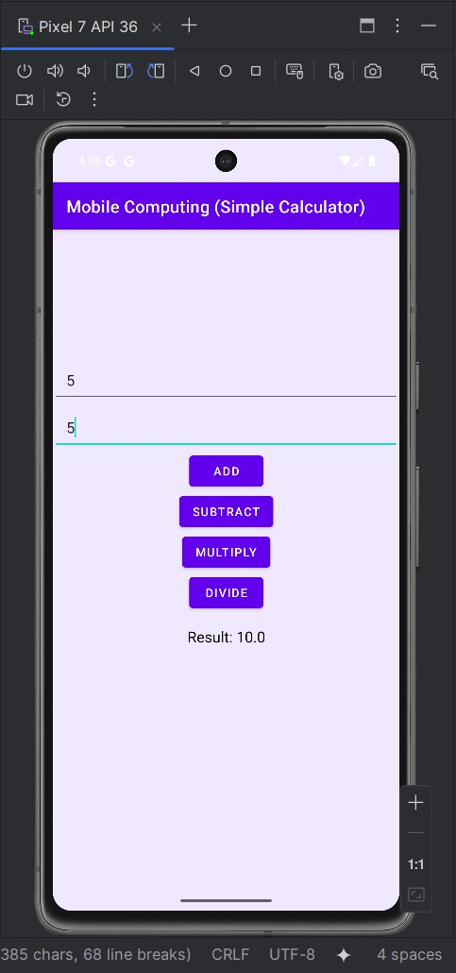
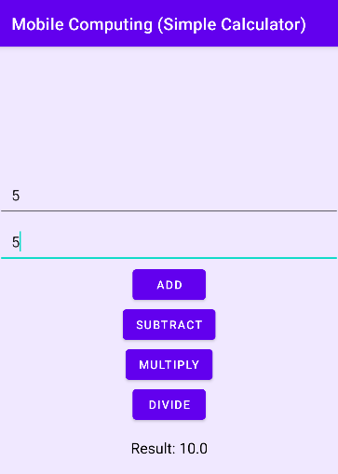
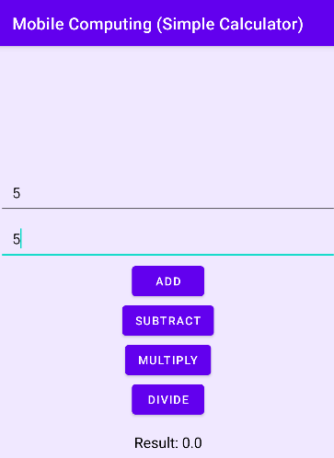

Practical No.5

Aim: Write a program to implement Intent.

MainActivity1.java
package com.example.experiment5; import android.content.Intent; import android.os.Bundle;
import androidx.appcompat.app.AppCompatActivity; import android.view.View;
public class MainActivity1 extends AppCompatActivity { @Override
protected void onCreate(Bundle savedInstanceState) {
super.onCreate(savedInstanceState); setContentView(R.layout.activity_main1);

if (getSupportActionBar() != null) { getSupportActionBar().setTitle(getString(R.string.app_name_page1));
}
}

public void Intenter(View view) {
Intent intent = new Intent(this, MainActivity2.class); startActivity(intent);
}
}

Activity_Main1.xml
<?xml version="1.0" encoding="utf-8"?>
<androidx.constraintlayout.widget.ConstraintLayout xmlns:android="http://schemas.android.com/apk/res/android"
xmlns:app="http://schemas.android.com/apk/res-auto" xmlns:tools="http://schemas.android.com/tools" android:layout_width="match_parent" android:layout_height="match_parent"

tools:context=".MainActivity1">
<LinearLayout android:layout_width="match_parent" android:layout_height="match_parent" android:orientation="vertical" android:gravity="center">
<Button android:id="@+id/Div"
android:layout_width="wrap_content" android:layout_height="wrap_content" android:onClick="Intenter" android:text="Next Page >" />
</LinearLayout></androidx.constraintlayout.widget.ConstraintLayout>

MainActivity2.java
package com.example.experiment5; import android.os.Bundle;
import androidx.appcompat.app.AppCompatActivity; public class MainActivity2 extends AppCompatActivity {

@Override
protected void onCreate(Bundle savedInstanceState) { super.onCreate(savedInstanceState); setContentView(R.layout.activity_main2);

if (getSupportActionBar() != null) { getSupportActionBar().setTitle(getString(R.string.app_name_page2));
}
}
}

Activity_Main2.xml
<?xml version="1.0" encoding="utf-8"?>
<androidx.constraintlayout.widget.ConstraintLayout xmlns:android="http://schemas.android.com/apk/res/android"
xmlns:app="http://schemas.android.com/apk/res-auto" xmlns:tools="http://schemas.android.com/tools" android:layout_width="match_parent"

android:layout_height="match_parent" tools:context=".MainActivity2">

<TextView android:id="@+id/textView" android:layout_width="282dp" android:layout_height="121dp" android:textAlignment="center"
android:text="Welcome to the New Page" android:textSize="34sp" app:layout_constraintBottom_toBottomOf="parent" app:layout_constraintTop_toTopOf="parent" app:layout_constraintStart_toStartOf="parent" app:layout_constraintEnd_toEndOf="parent" />
</androidx.constraintlayout.widget.ConstraintLayout>

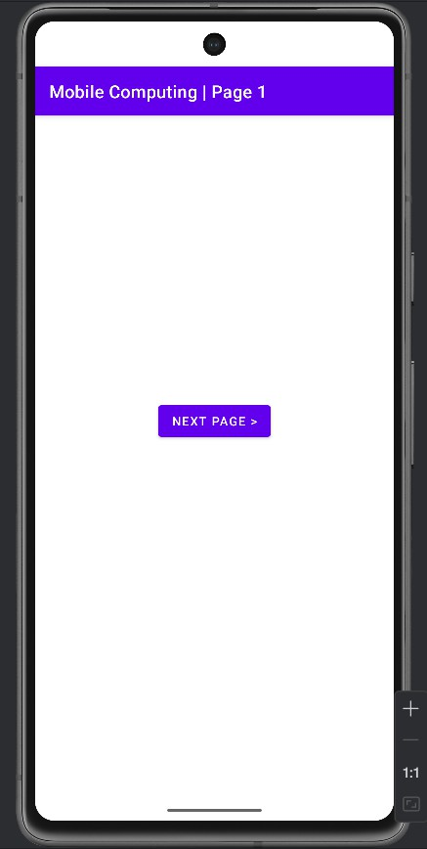
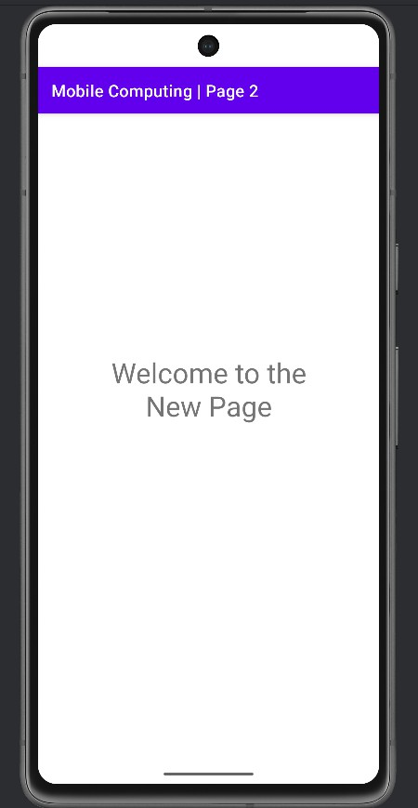
OUTPUT:

Practical No.6

Aim: Create an Android application display registration form using UI components.

MainActivity.java

Activity_Main.xml

OUTPUT:

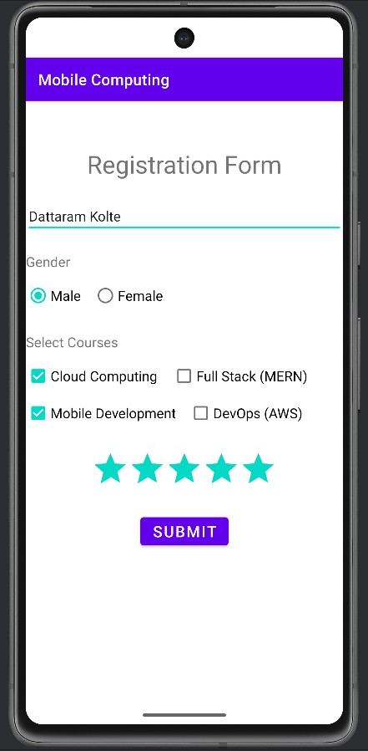
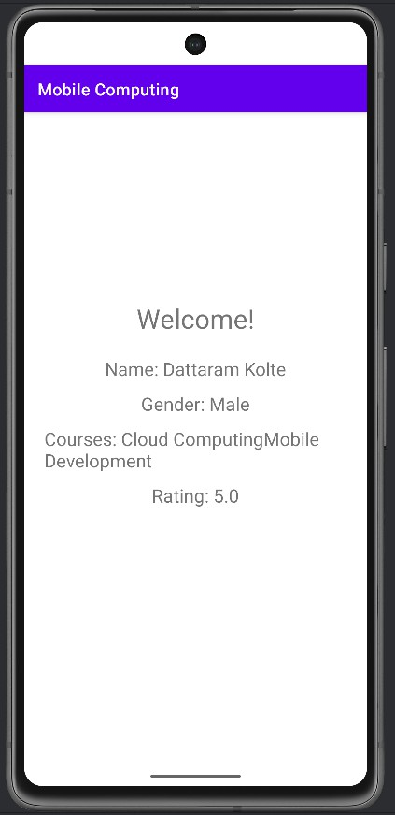

Practical No.7

Aim:

MainActivity.java
package com.example.experiment7; import android.os.Bundle;
import android.view.View; import android.widget.Button;
import android.widget.ImageView;
import androidx.appcompat.app.AppCompatActivity; public class MainActivity extends AppCompatActivity {
@Override
protected void onCreate(Bundle savedInstanceState) { super.onCreate(savedInstanceState); setContentView(R.layout.activity_main);
Button btn1 = findViewById(R.id.bt1); ImageView iv = findViewById(R.id.iv2);

btn1.setOnClickListener(new View.OnClickListener() { @Override
public void onClick(View view) { iv.setImageResource(R.drawable.android);
}
});
}}

Activity_Main.xml
<RelativeLayout xmlns:android="http://schemas.android.com/apk/res/android" android:layout_width="match_parent"
android:layout_height="match_parent" android:fitsSystemWindows="true"
>
<ImageView android:id="@+id/iv2"

android:layout_width="match_parent" android:layout_height="667dp" android:layout_alignParentStart="true" android:layout_alignParentTop="true" android:layout_marginBottom="19dp" android:src="@drawable/ic_launcher_foreground" />
<Button android:id="@+id/bt1"
android:layout_width="wrap_content" android:layout_height="wrap_content" android:text="Change Image" android:textSize="28dp" android:layout_alignParentBottom="true" android:layout_centerHorizontal="true" android:layout_marginBottom="60dp"
/>
</RelativeLayout>

OUTPUT:
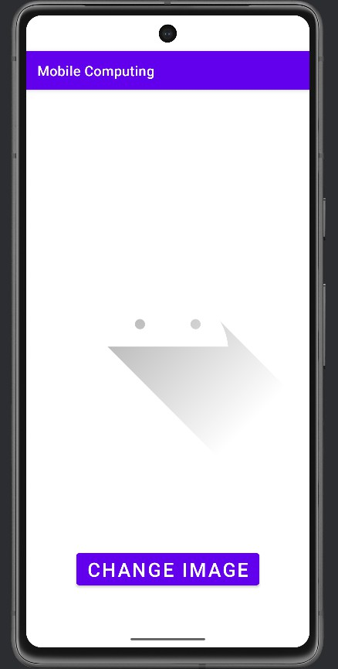
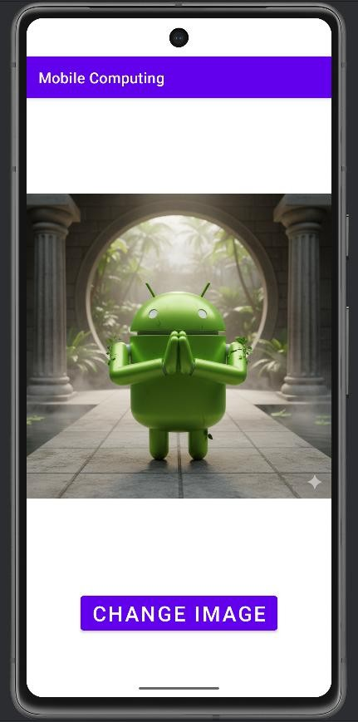

Practical No.8

Aim:

MainActivity.java
package com.example.experiment8; import android.os.Bundle;
import androidx.appcompat.app.AppCompatActivity; public class MainActivity extends AppCompatActivity {
@Override
protected void onCreate(Bundle savedInstanceState) { super.onCreate(savedInstanceState); setContentView(new Mview(this));
}
}

Mview.java
package com.example.experiment8;

import android.content.Context; import android.graphics.Canvas; import android.graphics.Color; import android.graphics.Paint; import android.view.View;

public class Mview extends View { Paint p;

public Mview(Context context) { super(context);
p = new Paint();
p.setStyle(Paint.Style.FILL); // Set paint style
}

@Override
protected void onDraw(Canvas canvas) { super.onDraw(canvas); p.setColor(Color.WHITE);

canvas.drawPaint(p); int width = getWidth(); int height = getHeight();
p.setColor(Color.YELLOW); int rad = 100;
canvas.drawCircle(width / 2, height / 2, rad, p); p.setColor(Color.RED);
int rectLeft = 100;
int rectTop = height / 4; int rectRight = width - 100;
int rectBottom = rectTop + 150;
canvas.drawRect(rectLeft, rectTop, rectRight, rectBottom, p);

}}

Activity_Main.xml
<?xml version="1.0" encoding="utf-8"?>
<androidx.constraintlayout.widget.ConstraintLayout xmlns:android="http://schemas.android.com/apk/res/android"
xmlns:app="http://schemas.android.com/apk/res-auto" xmlns:tools="http://schemas.android.com/tools" android:layout_width="match_parent" android:layout_height="match_parent" tools:context=".MainActivity">

<com.example.experiment8.Mview android:id="@+id/customView" android:layout_width="0dp" android:layout_height="0dp" app:layout_constraintTop_toTopOf="parent" app:layout_constraintBottom_toBottomOf="parent" app:layout_constraintStart_toStartOf="parent" app:layout_constraintEnd_toEndOf="parent" android:layout_marginTop="?attr/actionBarSize" />
</androidx.constraintlayout.widget.ConstraintLayout>

OUTPUT:
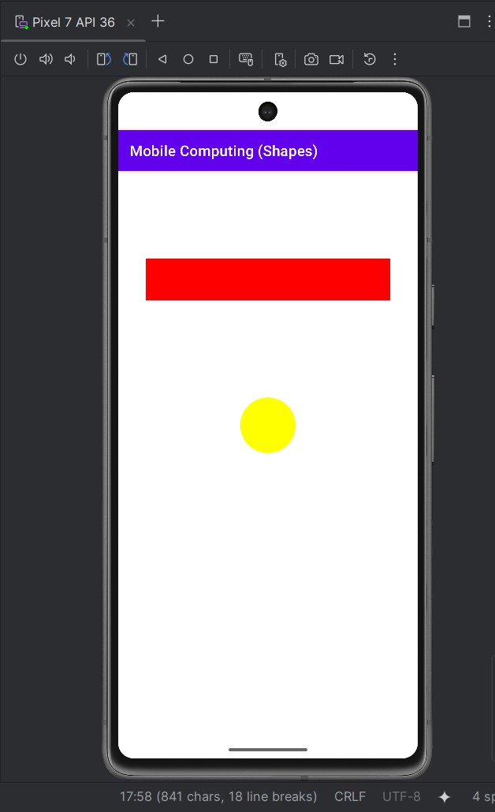

Practical No.9

Aim:

MainActivity.java
package com.example.experiment9; import android.content.DialogInterface; import android.os.Bundle;
import android.view.View; import android.widget.Button;
import androidx.appcompat.app.AlertDialog;
import androidx.appcompat.app.AppCompatActivity; public class MainActivity extends AppCompatActivity {
private Button btnCloseApp; @Override
protected void onCreate(Bundle savedInstanceState) {
super.onCreate(savedInstanceState); setContentView(R.layout.activity_main);

btnCloseApp = findViewById(R.id.btnCloseApp);

// Set button click listener btnCloseApp.setOnClickListener(new View.OnClickListener() {
@Override
public void onClick(View v) {
// Show confirmation dialog showExitDialog();
}
});
}

private void showExitDialog() {
// Create an AlertDialog
AlertDialog.Builder builder = new AlertDialog.Builder(MainActivity.this); builder.setMessage("Do you want to close this app?")
.setCancelable(false) // Make the dialog non-cancelable (No click outside to dismiss)

.setPositiveButton("Yes", new DialogInterface.OnClickListener() { @Override
public void onClick(DialogInterface dialog, int id) {
// Close the app finish();
}
})
.setNegativeButton("No", new DialogInterface.OnClickListener() { @Override
public void onClick(DialogInterface dialog, int id) {
// Dismiss the dialog, do nothing dialog.dismiss();
}
});

// Show the dialog
AlertDialog alert = builder.create(); alert.show();
}
}

Activity_Main.xml
<RelativeLayout xmlns:android="http://schemas.android.com/apk/res/android" android:layout_width="match_parent"
android:layout_height="match_parent">
<Button android:id="@+id/btnCloseApp" android:layout_width="wrap_content" android:layout_height="wrap_content" android:text="Close App"
android:layout_centerHorizontal="true" android:layout_centerVertical="true"/>

</RelativeLayout>

OUTPUT:
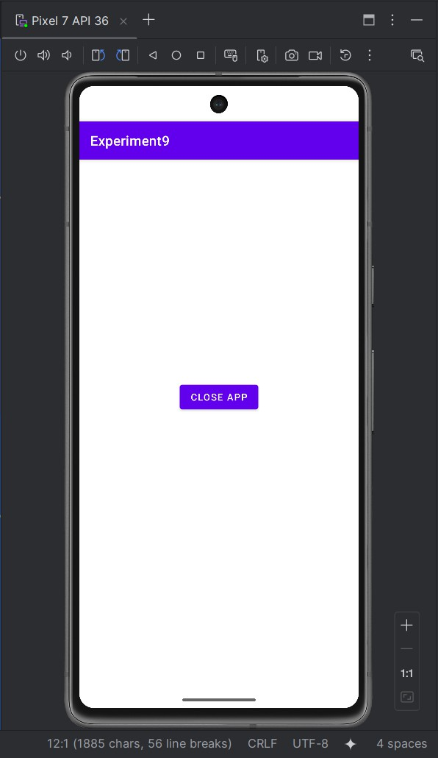
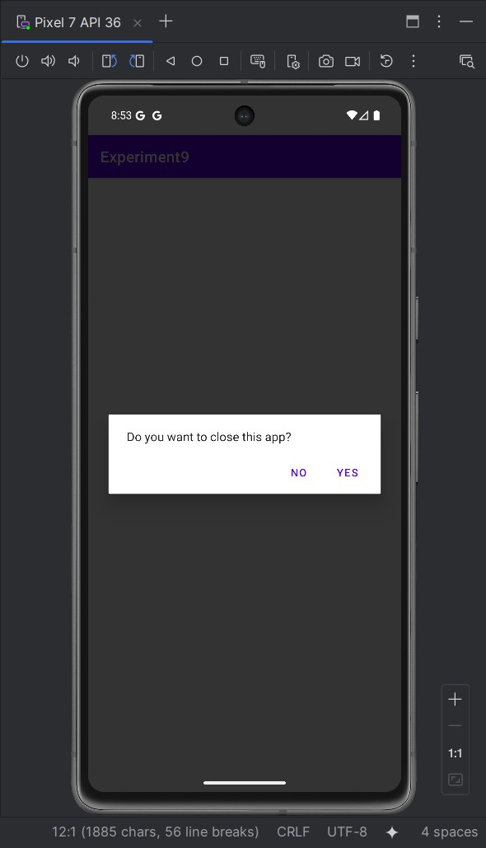
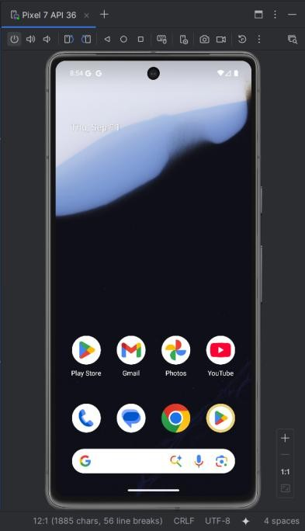

Practical No.10

Aim:

MainActivity.java
package com.example.expeirment10;
import androidx.appcompat.app.AppCompatActivity; import android.os.Bundle;
import android.content.Context; import android.view.View; import android.widget.EditText; import android.widget.TextView; import android.widget.Button; import android.widget.Toast;

import java.io.File;
import java.io.FileInputStream; import java.io.FileOutputStream;

public class MainActivity extends AppCompatActivity { EditText et_Text;
Button b_read, b_write, b_delete; TextView tv_Text;
String file_name = "file.txt"; @Override
protected void onCreate(Bundle savedInstanceState) { super.onCreate(savedInstanceState); setContentView(R.layout.activity_main);

et_Text = (EditText) findViewById(R.id.txtcontent); b_read = (Button) findViewById(R.id.btnread); b_write = (Button) findViewById(R.id.btnwrite); tv_Text = (TextView) findViewById(R.id.textView); b_delete = (Button) findViewById(R.id.btn_delete);
b_read.setOnClickListener(new View.OnClickListener() { @Override
public void onClick(View view) {
// Empty listener — you may want to add code here
}
});
tv_Text.setText(readFile(file_name)); b_write.setOnClickListener(new View.OnClickListener() {
@Override
public void onClick(View view) { saveFile(file_name, et_Text.getText().toString());

Toast.makeText(MainActivity.this, "saved text", Toast.LENGTH_SHORT).show();
}
});
}
public void saveFile(String file_name, String text) { try {
FileOutputStream fos = openFileOutput(file_name, Context.MODE_PRIVATE); fos.write(text.getBytes());
fos.close();
Toast.makeText(MainActivity.this, "", Toast.LENGTH_SHORT).show();
} catch (Exception e) { e.printStackTrace();
Toast.makeText(MainActivity.this, "Error saving file", Toast.LENGTH_SHORT).show();
}
}

public String readFile(String file_name) { String text = "";
try {
FileInputStream fis = openFileInput(file_name); int size = fis.available();
byte[] buffer = new byte[size]; fis.read(buffer);
fis.close();
text = new String(buffer);
} catch (Exception e) { e.printStackTrace(); runOnUiThread(new Runnable() {
@Override public void run() {
Toast.makeText(MainActivity.this, "Error Reading file", Toast.LENGTH_SHORT).show();
}
});
}
return text;
}
public void clearFile(View view) { et_Text.getText().clear();
}
public void deleteFile(View view) {
File file = new File(getFilesDir(), file_name); if (file.exists()) {
file.delete();
Toast.makeText(MainActivity.this, "file Deleted", Toast.LENGTH_SHORT).show();
} else {
Toast.makeText(MainActivity.this, "file not found", Toast.LENGTH_SHORT).show();
}
}
}

Activity_Main.xml
<?xml version="1.0" encoding="utf-8"?>
<RelativeLayout xmlns:android="http://schemas.android.com/apk/res/android" xmlns:app="http://schemas.android.com/apk/res-auto" xmlns:tools="http://schemas.android.com/tools" android:layout_width="match_parent" android:layout_height="match_parent" tools:context=".MainActivity">
<EditText android:id="@+id/txtcontent"
android:layout_width="match_parent" android:layout_height="65dp" android:layout_marginStart="16dp" android:layout_marginEnd="16dp" android:layout_alignParentTop="true" android:layout_marginTop="31dp" android:ems="10" android:inputType="textPersonName" />
<Button
android:id="@+id/btnwrite" android:layout_width="103dp" android:layout_height="wrap_content" android:layout_alignStart="@+id/txtcontent" android:layout_alignLeft="@+id/txtcontent" android:layout_alignTop="@+id/btnread" android:text="Write" />
<Button
android:id="@+id/btnread" android:layout_width="100dp" android:layout_height="wrap_content" android:layout_alignParentTop="true" android:layout_centerHorizontal="true" android:layout_marginTop="170dp" android:text="Read" />
<TextView android:id="@+id/textView" android:layout_width="259dp" android:layout_height="55dp"
android:layout_alignParentStart="true" android:layout_alignParentLeft="true" android:layout_alignParentBottom="true" android:layout_marginStart="43dp" android:layout_marginLeft="43dp" android:layout_marginBottom="59dp" android:text="TextView" />
<Button
android:id="@+id/btn_clear"

android:layout_width="101dp" android:layout_height="wrap_content" android:layout_alignTop="@+id/btnwrite" android:layout_alignParentEnd="true" android:layout_alignParentRight="true" android:layout_marginStart="12dp" android:layout_marginLeft="12dp" android:layout_marginTop="1dp" android:layout_marginEnd="42dp" android:layout_marginRight="42dp" android:layout_toEndOf="@+id/btnread" android:layout_toRightOf="@+id/btnread" android:onClick="clearFile" android:text="Clear" />
<Button
android:id="@+id/btn_delete" android:layout_width="213dp" android:layout_height="wrap_content" android:layout_alignTop="@+id/btn_clear" android:layout_alignParentEnd="true" android:layout_alignParentRight="true" android:layout_marginTop="78dp" android:layout_marginEnd="88dp" android:layout_marginRight="88dp" android:onClick="deleteFile" android:text="Delete" />
</RelativeLayout>

OUTPUT:
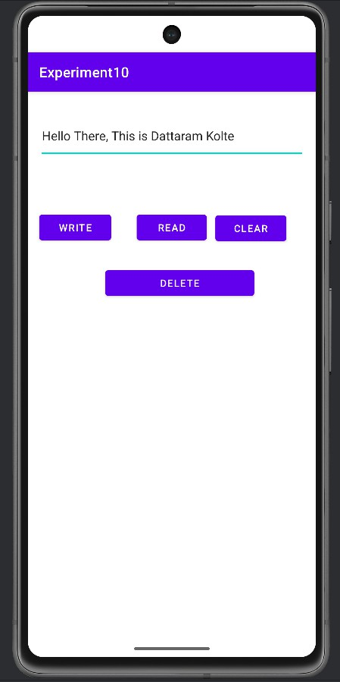
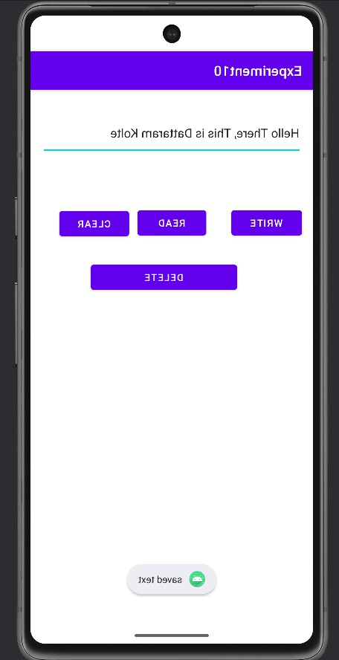

Practical No.11 & 12

Aim:

MainActivity.java
package com.example.experiment11and12;
public class MainActivity extends AppCompatActivity {

Switch wifiiii, bluetooot; WifiManager wifiManager;
BluetoothAdapter bluetoothAdapter = BluetoothAdapter.getDefaultAdapter();

private final ActivityResultLauncher<String[]> requestBluetoothPermissionsLauncher = registerForActivityResult(new ActivityResultContracts.RequestMultiplePermissions(), result ->
{
Boolean bluetoothConnectGranted =
result.getOrDefault(Manifest.permission.BLUETOOTH_CONNECT, false); Boolean bluetoothScanGranted =
result.getOrDefault(Manifest.permission.BLUETOOTH_SCAN, false);

if (Boolean.TRUE.equals(bluetoothConnectGranted)) { enableOrDisableBluetooth(bluetooot.isChecked());
} else {
Toast.makeText(this, "Bluetooth permission denied. Cannot control Bluetooth.", Toast.LENGTH_LONG).show();
bluetooot.setChecked(false);
}
});

private final ActivityResultLauncher<Intent> requestEnableBluetoothLauncher = registerForActivityResult(new ActivityResultContracts.StartActivityForResult(), result -> {
if (result.getResultCode() == RESULT_OK) { Toast.makeText(getApplicationContext(), "Bluetooth Turned ON",
Toast.LENGTH_SHORT).show();
} else {
Toast.makeText(getApplicationContext(), "Bluetooth enabling cancelled", Toast.LENGTH_SHORT).show();
bluetooot.setChecked(false);

}
});

@Override
protected void onCreate(Bundle savedInstanceState) { super.onCreate(savedInstanceState); EdgeToEdge.enable(this); setContentView(R.layout.activity_main);

wifiManager = (WifiManager) getApplicationContext().getSystemService(Context.WIFI_SERVICE); wifiiii = findViewById(R.id.switch1);
wifiiii.setOnCheckedChangeListener((buttonView, isChecked) -> { if (isChecked) {
if (Build.VERSION.SDK_INT >= Build.VERSION_CODES.Q) {
Toast.makeText(MainActivity.this, "Please enable Wi-Fi from System Settings", Toast.LENGTH_LONG).show();
startActivity(new Intent(android.provider.Settings.Panel.ACTION_WIFI));
} else {
wifiManager.setWifiEnabled(true);
Toast.makeText(MainActivity.this, "WIFI ON", Toast.LENGTH_SHORT).show();
}
} else {
if (Build.VERSION.SDK_INT >= Build.VERSION_CODES.Q) {
Toast.makeText(MainActivity.this, "Please disable Wi-Fi from System Settings", Toast.LENGTH_LONG).show();
startActivity(new Intent(android.provider.Settings.Panel.ACTION_WIFI));
} else {
wifiManager.setWifiEnabled(false);
Toast.makeText(MainActivity.this, "WIFI Off", Toast.LENGTH_SHORT).show();
}
}
});

bluetooot = findViewById(R.id.switch3); bluetooot.setOnCheckedChangeListener((buttonView, isChecked) ->
handleBluetoothSwitch(isChecked));
}

private void handleBluetoothSwitch(boolean isChecked) { if (bluetoothAdapter == null) {

Toast.makeText(getApplicationContext(), "Bluetooth not supported", Toast.LENGTH_SHORT).show();
bluetooot.setChecked(false); return;
}

if (Build.VERSION.SDK_INT >= Build.VERSION_CODES.S) {
if (ContextCompat.checkSelfPermission(this, Manifest.permission.BLUETOOTH_CONNECT) == PackageManager.PERMISSION_GRANTED) {
enableOrDisableBluetooth(isChecked);
} else {
requestBluetoothPermissionsLauncher.launch(new String[]{Manifest.permission.BLUETOOTH_CONNECT, Manifest.permission.BLUETOOTH_SCAN});
}
} else {
enableOrDisableBluetooth(isChecked);
}
}

@RequiresPermission(Manifest.permission.BLUETOOTH_CONNECT) private void enableOrDisableBluetooth(boolean enable) {
if (bluetoothAdapter == null) { Toast.makeText(getApplicationContext(), "Bluetooth not supported",
Toast.LENGTH_SHORT).show(); return;
}

if (enable) {
if (!bluetoothAdapter.isEnabled()) {
if (Build.VERSION.SDK_INT < Build.VERSION_CODES.S ||
ContextCompat.checkSelfPermission(this, Manifest.permission.BLUETOOTH_CONNECT) == PackageManager.PERMISSION_GRANTED) {
requestEnableBluetoothLauncher.launch(new Intent(BluetoothAdapter.ACTION_REQUEST_ENABLE));
} else {
Toast.makeText(getApplicationContext(), "Bluetooth connect permission needed to enable Bluetooth.", Toast.LENGTH_LONG).show();
bluetooot.setChecked(false);
}
} else {

Toast.makeText(getApplicationContext(), "Bluetooth is already ON", Toast.LENGTH_SHORT).show();
}
} else {
if (Build.VERSION.SDK_INT < Build.VERSION_CODES.S ||
ContextCompat.checkSelfPermission(this, Manifest.permission.BLUETOOTH_CONNECT) == PackageManager.PERMISSION_GRANTED) {
if (bluetoothAdapter.isEnabled()) { bluetoothAdapter.disable();
Toast.makeText(getApplicationContext(), "Bluetooth Turned Off", Toast.LENGTH_SHORT).show();
} else {
Toast.makeText(getApplicationContext(), "Bluetooth is already OFF", Toast.LENGTH_SHORT).show();
}
} else {
Toast.makeText(getApplicationContext(), "Bluetooth connect permission needed to disable Bluetooth.", Toast.LENGTH_LONG).show();
bluetooot.setChecked(true);
}
}
}
}

Activity_Main.xml
<?xml version="1.0" encoding="utf-8"?>
<androidx.constraintlayout.widget.ConstraintLayout xmlns:android="http://schemas.android.com/apk/res/android"
xmlns:app="http://schemas.android.com/apk/res-auto" xmlns:tools="http://schemas.android.com/tools" android:layout_width="match_parent" android:layout_height="match_parent" tools:context=".MainActivity">
<TextView android:id="@+id/tv1" android:layout_width="228dp" android:layout_height="33dp"
android:text="WIFI Enable/Disable" android:textSize="24sp" app:layout_constraintBottom_toBottomOf="parent"

app:layout_constraintHorizontal_bias="0.164" app:layout_constraintLeft_toLeftOf="parent" app:layout_constraintRight_toRightOf="parent" app:layout_constraintTop_toTopOf="parent" app:layout_constraintVertical_bias="0.394" />
<TextView android:id="@+id/tv" android:layout_width="269dp" android:layout_height="55dp"
android:text="Bluetooth Enable/Disable" android:textSize="24sp" app:layout_constraintBottom_toBottomOf="parent" app:layout_constraintHorizontal_bias="0.163" app:layout_constraintLeft_toLeftOf="parent" app:layout_constraintRight_toRightOf="parent" app:layout_constraintTop_toTopOf="parent" />
<Switch android:id="@+id/switch1"
android:layout_width="wrap_content" android:layout_height="wrap_content" android:layout_marginStart="36dp" android:textOff="OFF" android:textOn="ON"
app:layout_constraintBottom_toBottomOf="parent" app:layout_constraintEnd_toEndOf="parent" app:layout_constraintHorizontal_bias="0.0" app:layout_constraintStart_toEndOf="@+id/tv1" app:layout_constraintTop_toTopOf="parent" app:layout_constraintVertical_bias="0.399" />
<Switch android:id="@+id/switch3"
android:layout_width="wrap_content" android:layout_height="wrap_content" android:textOff="OFF" android:textOn="ON"
app:layout_constraintBottom_toBottomOf="parent" app:layout_constraintEnd_toEndOf="parent" app:layout_constraintStart_toEndOf="@+id/tv" app:layout_constraintTop_toTopOf="parent" />
</androidx.constraintlayout.widget.ConstraintLayout>

OUTPUT:
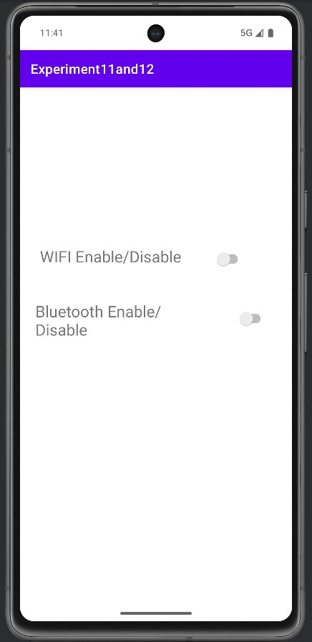
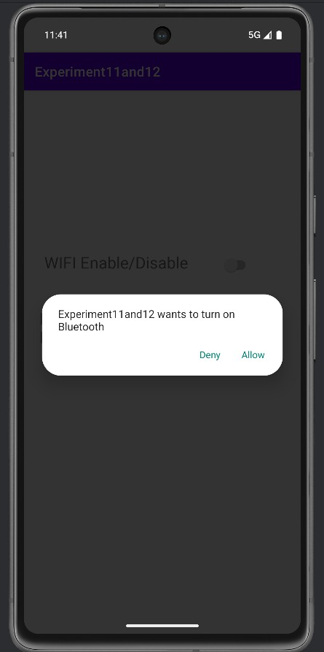
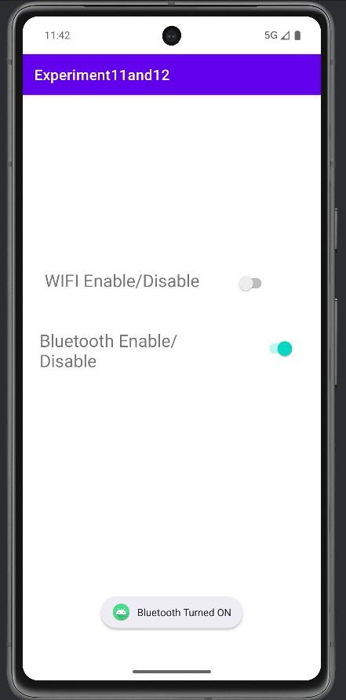
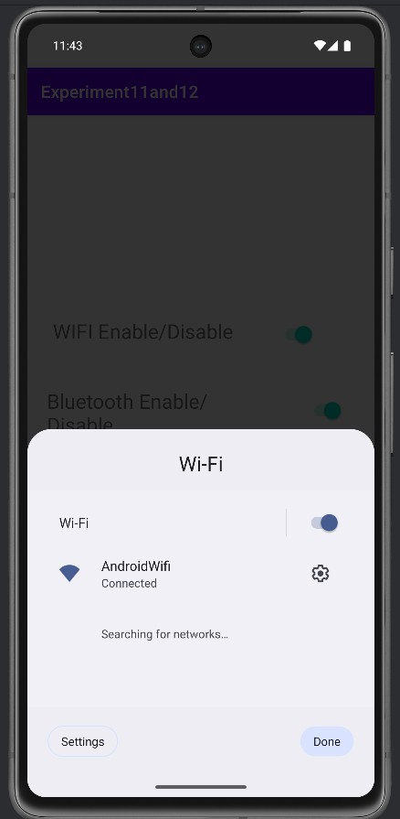

Practical No.13

Aim:

MainActivity.java
package com.example.experiment13;
public class MainActivity extends AppCompatActivity implements View.OnClickListener { SQLiteDatabase db;
EditText editSearchContact, editName, editEmailAddress, editMessage; Button btnSave, btnDelete, btnModify, btnView, btnSearch;

@Override
protected void onCreate(Bundle savedInstanceState) { super.onCreate(savedInstanceState); setContentView(R.layout.activity_main);

db = openOrCreateDatabase("ContactDb", Context.MODE_PRIVATE, null); db.execSQL("CREATE TABLE IF NOT EXISTS Contact(cId INTEGER PRIMARY KEY
AUTOINCREMENT, Name VARCHAR, Mail VARCHAR, CMessage VARCHAR);");

editSearchContact = findViewById(R.id.editTextSearch); editName = findViewById(R.id.editTextName); editEmailAddress = findViewById(R.id.editTextEmailAddress); editMessage = findViewById(R.id.editTextMessage);
btnSave = findViewById(R.id.btnsave); btnDelete = findViewById(R.id.btndel); btnModify = findViewById(R.id.btnupdate); btnView = findViewById(R.id.btnselect);
btnSearch = findViewById(R.id.btnselectperticular);

btnSave.setOnClickListener(this); btnDelete.setOnClickListener(this); btnModify.setOnClickListener(this); btnView.setOnClickListener(this); btnSearch.setOnClickListener(this);
}

private void showMessage(Context context, String message) {

Toast.makeText(context, message, Toast.LENGTH_SHORT).show();
}

@Override
public void onClick(View v) {
if (v.getId() == R.id.btnsave) { saveData();
} else if (v.getId() == R.id.btnupdate) { updateData();
} else if (v.getId() == R.id.btndel) { deleteData();
} else if (v.getId() == R.id.btnselect) { selectAllData();
} else if (v.getId() == R.id.btnselectperticular) { selectParticularData();
}
}

private void saveData() {
if (isAnyFieldEmpty(editName, editEmailAddress, editMessage)) { showMessage(this, "Please enter all values");
return;
}

String sql = "INSERT INTO Contact(Name, Mail, CMessage) VALUES (?, ?, ?)"; db.execSQL(sql, new Object[]{
editName.getText().toString(), editEmailAddress.getText().toString(), editMessage.getText().toString()
});

clearFields();
showMessage(this, "Response Noted, Thanks!!");
}

private void updateData() {
if (editSearchContact.getText().toString().trim().isEmpty()) { showMessage(this, "Enter Name");
return;
}

Cursor c = db.rawQuery("SELECT * FROM Contact WHERE Name = ?", new String[]{editSearchContact.getText().toString()});
if (c.moveToFirst()) {
String sql = "UPDATE Contact SET Name = ?, Mail = ?, CMessage = ? WHERE Name = ?"; db.execSQL(sql, new Object[]{
editName.getText().toString(), editEmailAddress.getText().toString(), editMessage.getText().toString(), editSearchContact.getText().toString()
});

clearFields(); editSearchContact.getText().clear(); showMessage(this, "Record Modified");
} else {
showMessage(this, "Invalid Name");
}
c.close();
}

private void deleteData() {
if (editSearchContact.getText().toString().trim().isEmpty()) { showMessage(this, "Please enter Name");
return;
}

Cursor c = db.rawQuery("SELECT * FROM Contact WHERE Name = ?", new String[]{editSearchContact.getText().toString()});
if (c.moveToFirst()) {
db.execSQL("DELETE FROM Contact WHERE Name = ?", new String[]{editSearchContact.getText().toString()});
clearFields();
showMessage(this, "Record Deleted");
} else {
showMessage(this, "Invalid Name");
}
c.close();
}

private void selectAllData() {
Cursor c = db.rawQuery("SELECT * FROM Contact", null); if (c.getCount() == 0) {
showMessage(this, "No records found"); return;
}

StringBuilder buffer = new StringBuilder(); while (c.moveToNext()) {
buffer.append("Name: ").append(c.getString(1)).append("\n");
buffer.append("Mail: ").append(c.getString(2)).append("\n"); buffer.append("Message: ").append(c.getString(3)).append("\n\n");
}

showMessage(this, buffer.toString()); c.close();
}

private void selectParticularData() {
if (editSearchContact.getText().toString().trim().isEmpty()) { showMessage(this, "Enter Name");
return;
}

Cursor c = db.rawQuery("SELECT * FROM Contact WHERE Name = ?", new String[]{editSearchContact.getText().toString()});
if (c.moveToFirst()) { editName.setText(c.getString(1)); editEmailAddress.setText(c.getString(2)); editMessage.setText(c.getString(3));
} else {
showMessage(this, "Invalid Name");
}
c.close();
}

private boolean isAnyFieldEmpty(EditText... fields) { for (EditText field : fields) {
if (field.getText().toString().trim().isEmpty()) { return true;

}
}
return false;
}

private void clearFields() { editName.getText().clear(); editEmailAddress.getText().clear(); editMessage.getText().clear();
}
}

Activity_Main.xml
<RelativeLayout xmlns:android="http://schemas.android.com/apk/res/android" android:layout_width="match_parent"
android:layout_height="match_parent" xmlns:tools="http://schemas.android.com/tools" tools:context=".MainActivity" android:fitsSystemWindows="true" xmlns:app="http://schemas.android.com/apk/res-auto">

<TextView android:id="@+id/textView5" android:layout_width="wrap_content" android:layout_height="wrap_content" android:layout_marginStart="122dp" android:layout_marginTop="24dp" android:text="Contact Us" android:textSize="18sp" android:textStyle="bold" app:fontFamily="serif" />

<EditText android:id="@+id/editTextName" android:layout_width="match_parent" android:layout_height="wrap_content" android:layout_marginStart="67dp" android:layout_marginTop="99dp" android:hint="Enter Your Name" android:inputType="textPersonName"/>

<EditText android:id="@+id/editTextEmailAddress" android:layout_width="match_parent" android:layout_height="wrap_content" android:layout_marginStart="67dp" android:layout_marginTop="145dp" android:hint="Enter Your Email Address" android:inputType="textEmailAddress"/>

<EditText android:id="@+id/editTextMessage" android:layout_width="match_parent" android:layout_height="wrap_content" android:layout_marginStart="67dp" android:layout_marginTop="196dp" android:hint="Enter Your Message" android:inputType="textMultiLine"/>

<Button android:id="@+id/btnsave"
android:layout_width="wrap_content" android:layout_height="wrap_content" android:layout_below="@id/editTextMessage" android:layout_marginStart="50dp" android:layout_marginTop="16dp" android:text="Save" />

<Button android:id="@+id/btnupdate"
android:layout_width="wrap_content" android:layout_height="wrap_content" android:layout_below="@id/editTextMessage" android:layout_marginStart="150dp" android:layout_marginTop="16dp" android:text="Update" />

<Button android:id="@+id/btndel"
android:layout_width="wrap_content"

android:layout_height="wrap_content" android:layout_below="@id/editTextMessage" android:layout_marginStart="250dp" android:layout_marginTop="16dp" android:text="Delete" />

<Button android:id="@+id/btnselect"
android:layout_width="wrap_content" android:layout_height="wrap_content" android:layout_below="@id/btnsave" android:layout_marginTop="16dp" android:text="View" />

<Button android:id="@+id/btnselectperticular" android:layout_width="wrap_content" android:layout_height="wrap_content" android:layout_below="@id/btnselect" android:layout_marginTop="16dp" android:text="Search" />

<EditText android:id="@+id/editTextSearch" android:layout_width="match_parent" android:layout_height="wrap_content"
android:layout_below="@id/btnselectperticular" android:layout_marginTop="16dp" android:hint="Search" android:inputType="text"/>
</RelativeLayout>

OUTPUT:
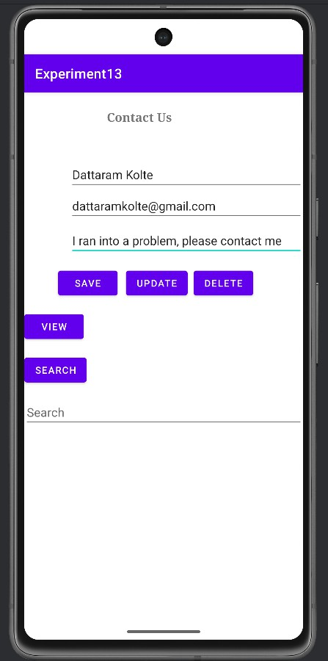
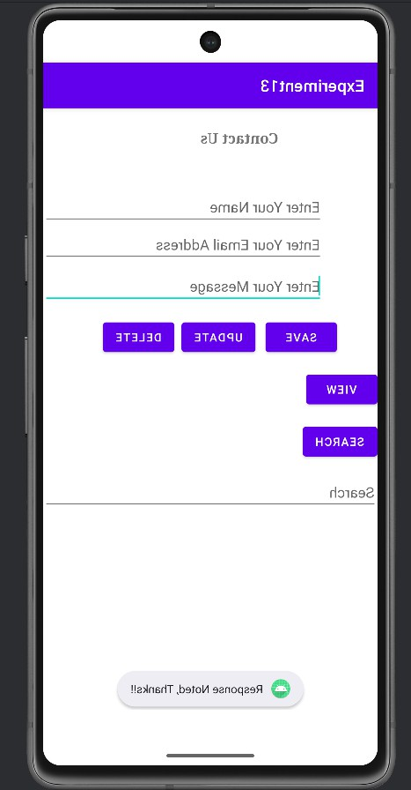
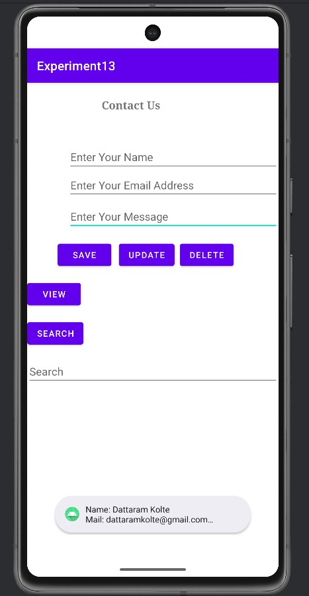
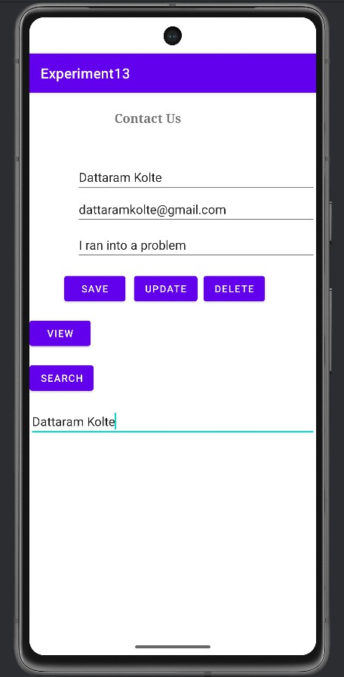
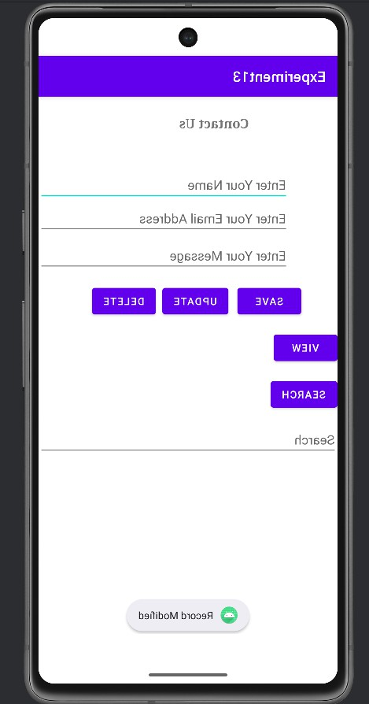

Practical No.14

Aim:

MainActivity.java
package com.example.experiment14;

import android.os.Bundle; import android.view.View;
import android.view.animation.Animation; import android.view.animation.AnimationUtils; import android.widget.ImageView;
import androidx.activity.EdgeToEdge;
import androidx.appcompat.app.AppCompatActivity; public class MainActivity extends AppCompatActivity {
private ImageView imageView;

@Override
protected void onCreate(Bundle savedInstanceState) { super.onCreate(savedInstanceState); EdgeToEdge.enable(this); setContentView(R.layout.activity_main);
imageView = findViewById(R.id.imageView);

}

public void move(View view) { startAnimation(R.anim.move);
}

public void fade(View view) { startAnimation(R.anim.fade_in);
}

public void rotate(View view) { startAnimation(R.anim.rotate);

}

public void blink(View view) { startAnimation(R.anim.blink);
}

private void startAnimation(int animationResource) {
Animation animation = AnimationUtils.loadAnimation(getApplicationContext(), animationResource);
imageView.startAnimation(animation);
}
}

Acitivity_Main.xml
<?xml version="1.0" encoding="utf-8"?>
<RelativeLayout xmlns:android="http://schemas.android.com/apk/res/android" xmlns:app="http://schemas.android.com/apk/res-auto" xmlns:tools="http://schemas.android.com/tools" android:layout_width="match_parent"
android:layout_height="match_parent" android:fitsSystemWindows="true" tools:context=".MainActivity">

<ImageView android:id="@+id/imageView" android:layout_width="200dp" android:layout_height="200dp" android:layout_centerHorizontal="true" android:layout_marginTop="100dp" app:srcCompat="@drawable/android" />

<GridLayout android:id="@+id/gridLayout" android:layout_width="wrap_content" android:layout_height="wrap_content" android:layout_below="@id/imageView" android:layout_marginTop="40dp" android:columnCount="2" android:gravity="center"

android:layout_centerInParent="true">

<Button android:id="@+id/button"
android:layout_width="wrap_content" android:layout_height="wrap_content" android:text="Move" android:onClick="move" android:layout_margin="8dp" />

<Button android:id="@+id/button2"
android:layout_width="wrap_content" android:layout_height="wrap_content" android:text="Fade" android:onClick="fade" android:layout_margin="8dp" />

<Button android:id="@+id/button3"
android:layout_width="wrap_content" android:layout_height="wrap_content" android:text="Rotate" android:onClick="rotate" android:layout_margin="8dp" />

<Button android:id="@+id/button4"
android:layout_width="wrap_content" android:layout_height="wrap_content" android:text="Blink" android:onClick="blink" android:layout_margin="8dp" />
</GridLayout>
</RelativeLayout>

OUTPUT:
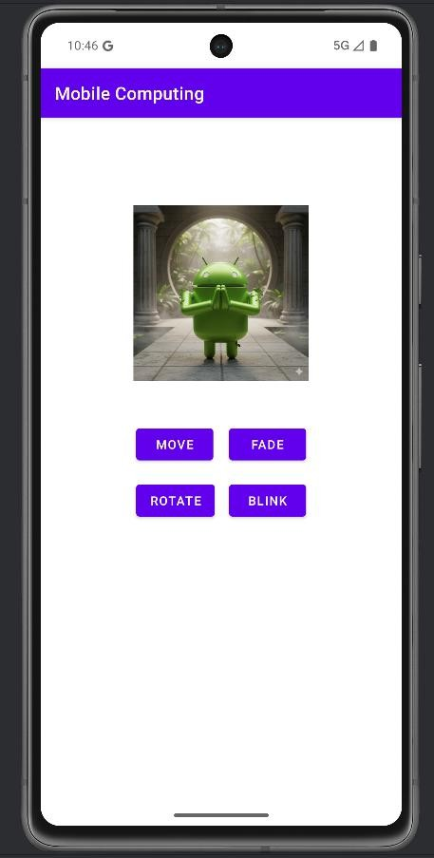
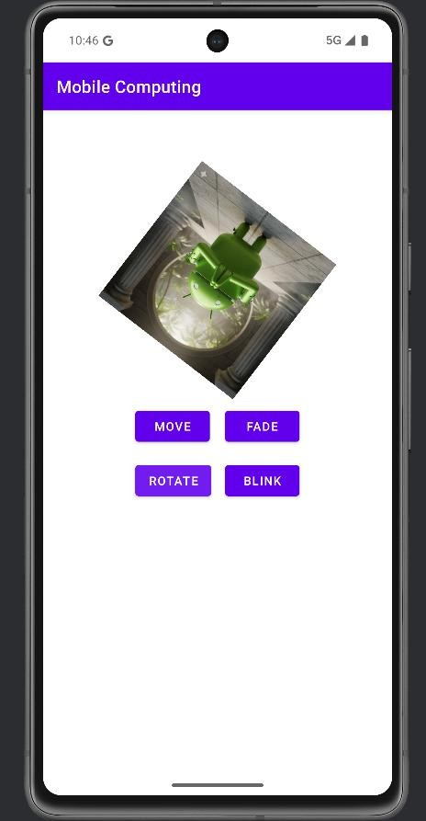
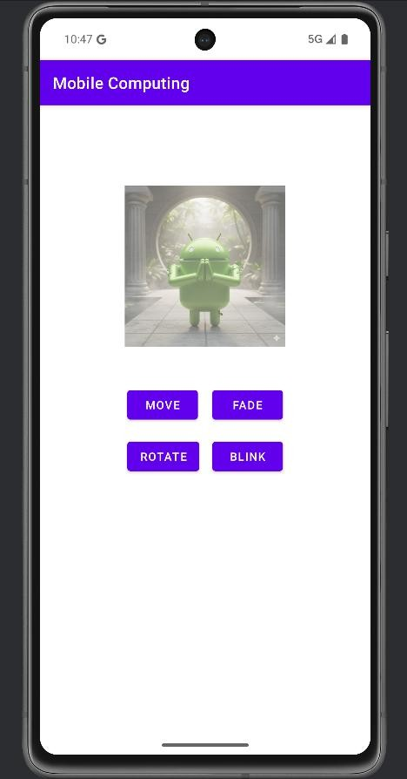

Practical No.15

Aim:

MainActivity.java
package com.example.experiment15;
public class MainActivity extends AppCompatActivity {

SharedPreferences sharedPreferences; TextView password;
TextView email; CheckBox remember;

public static final String mypreferences = "mypref"; public static final String Email = "emailKey";
public static final String Password = "passwordKey";

@Override
protected void onCreate(Bundle savedInstanceState) { super.onCreate(savedInstanceState); EdgeToEdge.enable(this); setContentView(R.layout.activity_main);

email = (TextView) findViewById(R.id.editText_email); password = (TextView) findViewById(R.id.editText_password); remember = (CheckBox) findViewById(R.id.checkBox);
sharedPreferences = getSharedPreferences(mypreferences, Context.MODE_PRIVATE); if (sharedPreferences.contains(Email)) {
email.setText(sharedPreferences.getString(Email, ""));
}

if (sharedPreferences.contains(Password)) { password.setText(sharedPreferences.getString(Password, " "));
}
}

public void Get(View view) {
email = (TextView) findViewById(R.id.editText_email); password = (TextView) findViewById(R.id.editText_password);
sharedPreferences = getSharedPreferences(mypreferences, Context.MODE_PRIVATE);

if (sharedPreferences.contains(Email)) { email.setText(sharedPreferences.getString(Email, " "));
}

if (sharedPreferences.contains(Password)) { password.setText(sharedPreferences.getString(Password, " "));
}
}

public void Save(View view) { if (remember.isChecked()) {
String e = email.getText().toString(); String p = password.getText().toString();
SharedPreferences.Editor editor = sharedPreferences.edit(); editor.putString(Email, e);
editor.putString(Password, p); editor.commit();

Toast toast = Toast.makeText(getApplicationContext(), "Value stored in shared preference", Toast.LENGTH_SHORT);
toast.show();
}
}

public void clear(View view) {
email = (TextView) findViewById(R.id.editText_email); password = (TextView) findViewById(R.id.editText_password); email.setText(" ");
password.setText(" ");
}
}

Acitivity_Main.xml

<?xml version="1.0" encoding="utf-8"?>
<androidx.constraintlayout.widget.ConstraintLayout xmlns:android="http://schemas.android.com/apk/res/android"
xmlns:app="http://schemas.android.com/apk/res-auto" xmlns:tools="http://schemas.android.com/tools" android:layout_width="match_parent" android:layout_height="match_parent" tools:context=".MainActivity">

<TextView android:id="@+id/textView_emailId" android:layout_width="wrap_content" android:layout_height="wrap_content" android:text="Email Id :" android:textSize="20sp"
app:layout_constraintBottom_toBottomOf="parent" app:layout_constraintEnd_toEndOf="parent" app:layout_constraintHorizontal_bias="0.095" app:layout_constraintStart_toStartOf="parent" app:layout_constraintTop_toTopOf="parent" app:layout_constraintVertical_bias="0.22" />

<TextView android:id="@+id/textView_password" android:layout_width="wrap_content" android:layout_height="wrap_content" android:text="Password :" android:textSize="20sp"
app:layout_constraintBottom_toBottomOf="parent" app:layout_constraintEnd_toEndOf="parent" app:layout_constraintHorizontal_bias="0.03" app:layout_constraintStart_toStartOf="parent" app:layout_constraintTop_toTopOf="parent" app:layout_constraintVertical_bias="0.351" />

<EditText android:id="@+id/editText_email" android:layout_width="202dp" android:layout_height="54dp"

android:ems="10" android:inputType="textPersonName" android:textSize="24sp" app:layout_constraintBottom_toBottomOf="parent" app:layout_constraintEnd_toEndOf="parent" app:layout_constraintHorizontal_bias="0.802" app:layout_constraintStart_toStartOf="parent" app:layout_constraintTop_toTopOf="parent" app:layout_constraintVertical_bias="0.227" />

<EditText android:id="@+id/editText_password" android:layout_width="191dp" android:layout_height="43dp" android:ems="10" android:inputType="textPersonName" android:textSize="24sp"
app:layout_constraintBottom_toBottomOf="parent" app:layout_constraintEnd_toEndOf="parent" app:layout_constraintHorizontal_bias="0.799" app:layout_constraintStart_toStartOf="parent" app:layout_constraintTop_toTopOf="parent" app:layout_constraintVertical_bias="0.372" />

<CheckBox android:id="@+id/checkBox" android:layout_width="wrap_content" android:layout_height="wrap_content" android:text="Remember Me" android:textSize="18sp"
app:layout_constraintBottom_toBottomOf="parent" app:layout_constraintEnd_toEndOf="parent" app:layout_constraintStart_toStartOf="parent" app:layout_constraintTop_toTopOf="parent" />

<Button android:id="@+id/button_signIn" android:layout_width="wrap_content" android:layout_height="wrap_content" android:onClick="Save"

android:text="Sign In" android:textSize="18sp"
app:layout_constraintBottom_toBottomOf="parent" app:layout_constraintEnd_toEndOf="parent" app:layout_constraintHorizontal_bias="0.216" app:layout_constraintStart_toStartOf="parent" app:layout_constraintTop_toTopOf="parent" app:layout_constraintVertical_bias="0.639" />

<Button android:id="@+id/button_clear" android:layout_width="wrap_content" android:layout_height="wrap_content" android:onClick="clear" android:text="Clear" android:textSize="18sp"
app:layout_constraintBottom_toBottomOf="parent" app:layout_constraintEnd_toEndOf="parent" app:layout_constraintHorizontal_bias="0.526" app:layout_constraintStart_toStartOf="parent" app:layout_constraintTop_toTopOf="parent" app:layout_constraintVertical_bias="0.758" />

<Button android:id="@+id/button_getData" android:layout_width="wrap_content" android:layout_height="wrap_content" android:onClick="Get" android:text="Get Data" android:textSize="18sp"
app:layout_constraintBottom_toBottomOf="parent" app:layout_constraintEnd_toEndOf="parent" app:layout_constraintHorizontal_bias="0.848" app:layout_constraintStart_toStartOf="parent" app:layout_constraintTop_toTopOf="parent" app:layout_constraintVertical_bias="0.639" />

</androidx.constraintlayout.widget.ConstraintLayout>

OUTPUT:
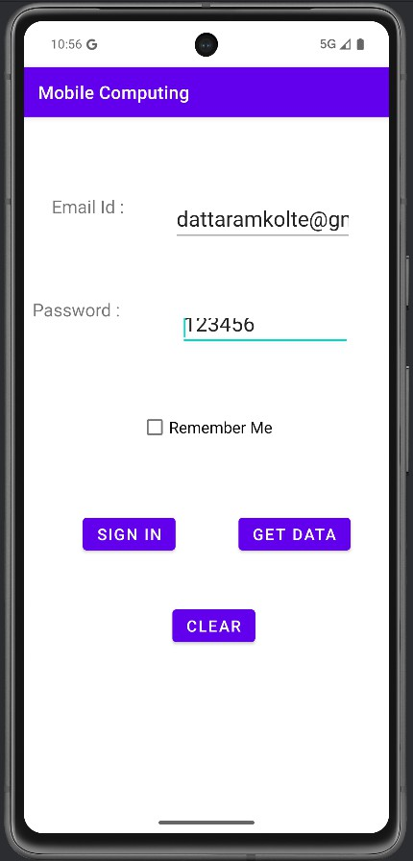
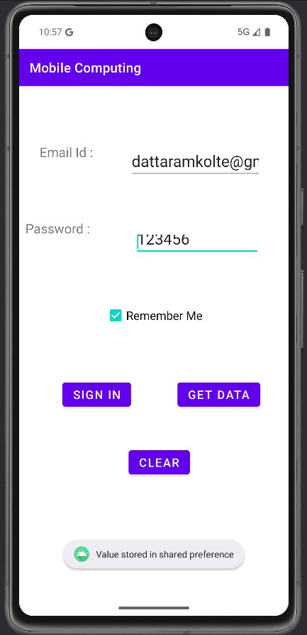
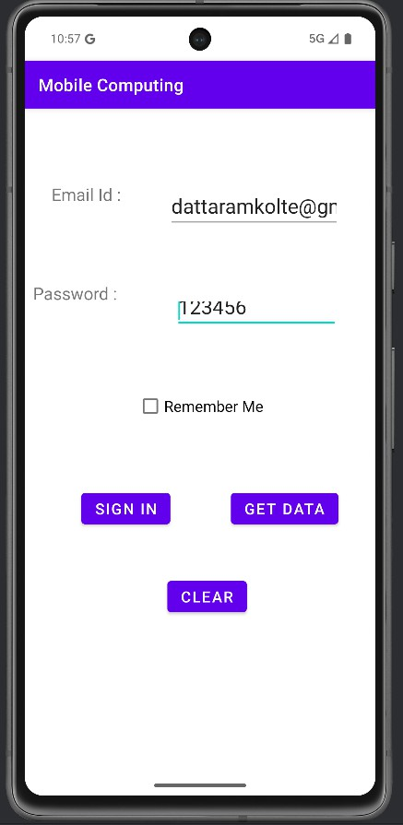

Practical No.16

Aim:

MainActivity.java
package com.example.experiment16;
public class MainActivity extends AppCompatActivity {

private ProgressDialog progressDialog; private Bitmap bitmap = null;
Button b1;

@Override
protected void onCreate(Bundle savedInstanceState) { super.onCreate(savedInstanceState); setContentView(R.layout.activity_main);
b1 = (Button) findViewById(R.id.button); b1.setOnClickListener(new View.OnClickListener() {
@Override
public void onClick(View v) { checkInternetConenction(); downloadImage
("https://hips.hearstapps.com/hmg-prod.s3.amazonaws.com/images/2022-chevrolet- corvette-z06-1607016574.jpg?crop=0.737xw:0.738xh;0.181xw,0.218xh&resize=980:*.jpg");
}
});
}

private void downloadImage(String urlStr) {
progressDialog = ProgressDialog.show(this, "", "Downloading Image from " + urlStr); final String url = urlStr;

new Thread() { public void run() {
InputStream in = null;
Message msg = Message.obtain();

msg.what = 1;

try {
in = openHttpConnection(url);
bitmap = BitmapFactory.decodeStream(in); Bundle b = new Bundle(); b.putParcelable("bitmap", bitmap); msg.setData(b);
in.close();
} catch (Exception e1) { e1.printStackTrace();
}

messageHandler.sendMessage(msg);
}
}.start();
}

private InputStream openHttpConnection(String urlStr) { InputStream in = null;
int resCode;

try {
URL url = new URL(urlStr);
URLConnection urlConn = url.openConnection();

if (!(urlConn instanceof HttpURLConnection)) { throw new IOException("URL is not an Http URL");
}

HttpURLConnection httpConn = (HttpURLConnection) urlConn; httpConn.setAllowUserInteraction(false); httpConn.setInstanceFollowRedirects(true); httpConn.setRequestMethod("GET");
httpConn.connect();
resCode = httpConn.getResponseCode();

if (resCode == HttpURLConnection.HTTP_OK) { in = httpConn.getInputStream();
}

} catch (MalformedURLException e) { e.printStackTrace();
} catch (IOException e) { e.printStackTrace();
}

return in;
}

private Handler messageHandler = new Handler() { public void handleMessage(Message msg) {
super.handleMessage(msg);
ImageView img = (ImageView) findViewById(R.id.imageView); img.setImageBitmap((Bitmap) (msg.getData().getParcelable("bitmap"))); progressDialog.dismiss();
}
};

private boolean checkInternetConenction() { ConnectivityManager connec = (ConnectivityManager)
getSystemService(getBaseContext().CONNECTIVITY_SERVICE);

if (connec.getNetworkInfo(0).getState() == android.net.NetworkInfo.State.CONNECTED || connec.getNetworkInfo(0).getState() == android.net.NetworkInfo.State.CONNECTING || connec.getNetworkInfo(1).getState() == android.net.NetworkInfo.State.CONNECTING || connec.getNetworkInfo(1).getState() == android.net.NetworkInfo.State.CONNECTED) {

Toast.makeText(this, "Connected", Toast.LENGTH_LONG).show(); return true;

} else if (connec.getNetworkInfo(0).getState() == android.net.NetworkInfo.State.DISCONNECTED
||
connec.getNetworkInfo(1).getState() == android.net.NetworkInfo.State.DISCONNECTED) {

Toast.makeText(this, "Not Connected", Toast.LENGTH_LONG).show(); return false;
}

return false;

}
}

Acitivity_Main.xml
<?xml version="1.0" encoding="utf-8"?>
<androidx.constraintlayout.widget.ConstraintLayout xmlns:android="http://schemas.android.com/apk/res/android"
xmlns:app="http://schemas.android.com/apk/res-auto" xmlns:tools="http://schemas.android.com/tools" android:layout_width="match_parent" android:layout_height="match_parent" tools:context=".MainActivity">

<TextView android:id="@+id/textView"
android:layout_width="wrap_content" android:layout_height="wrap_content" android:text="Web Page Image" android:textSize="25sp" app:layout_constraintBottom_toBottomOf="parent" app:layout_constraintEnd_toEndOf="parent" app:layout_constraintHorizontal_bias="0.486" app:layout_constraintStart_toStartOf="parent" app:layout_constraintTop_toTopOf="parent" app:layout_constraintVertical_bias="0.21" />

<ImageView android:id="@+id/imageView" android:layout_width="205dp" android:layout_height="262dp"
app:layout_constraintBottom_toBottomOf="parent" app:layout_constraintEnd_toEndOf="parent" app:layout_constraintStart_toStartOf="parent" app:layout_constraintTop_toTopOf="parent" app:layout_constraintVertical_bias="0.577" />

<Button android:id="@+id/button"
android:layout_width="wrap_content"

android:layout_height="wrap_content" android:text="Download"
android:textAppearance="@style/TextAppearance.AppCompat.Display1" app:layout_constraintBottom_toBottomOf="parent" app:layout_constraintEnd_toEndOf="parent" app:layout_constraintStart_toStartOf="parent" app:layout_constraintTop_toTopOf="parent" app:layout_constraintVertical_bias="0.863" />
</androidx.constraintlayout.widget.ConstraintLayout>

OUTPUT:
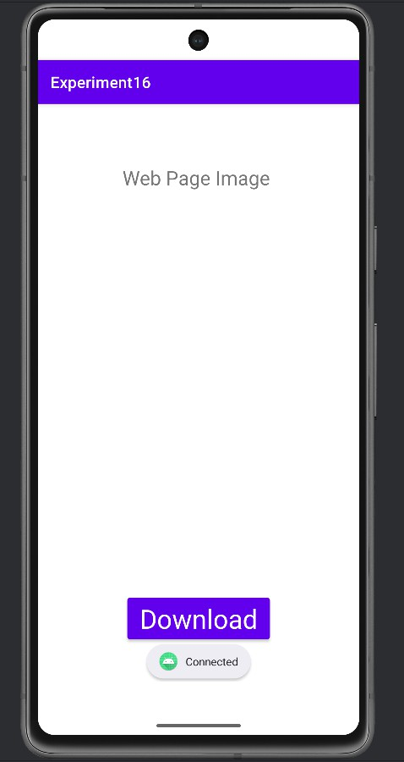
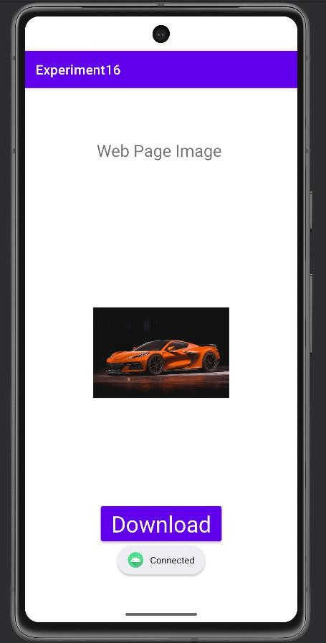

Practical No.17

Aim:

MainActivity.java
package com.example.experiment17;

import android.os.Bundle;
import android.widget.MediaController; import android.widget.VideoView;

import androidx.activity.EdgeToEdge;
import androidx.appcompat.app.AppCompatActivity; public class MainActivity extends AppCompatActivity {
VideoView videoid; MediaController mediaController;

@Override
protected void onCreate(Bundle savedInstanceState) { super.onCreate(savedInstanceState); EdgeToEdge.enable(this); setContentView(R.layout.activity_main);
videoid = findViewById(R.id.videoView1); mediaController = new MediaController(this);

// Set the video path from the raw resource folder videoid.setVideoPath("android.resource://" + getPackageName() + "/" + R.raw.nature); mediaController.setAnchorView(videoid); videoid.setMediaController(mediaController);
videoid.start();
}
}

Acitivity_Main.xml
<?xml version="1.0" encoding="utf-8"?>
<RelativeLayout xmlns:android="http://schemas.android.com/apk/res/android"

xmlns:tools="http://schemas.android.com/tools" android:layout_width="match_parent" android:layout_height="match_parent" tools:context=".MainActivity">

<VideoView android:id="@+id/videoView1" android:layout_width="match_parent" android:layout_height="wrap_content" android:layout_centerInParent="true" android:layout_margin="8dp" />

</RelativeLayout>

OUTPUT:

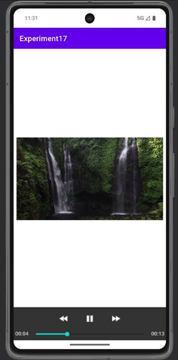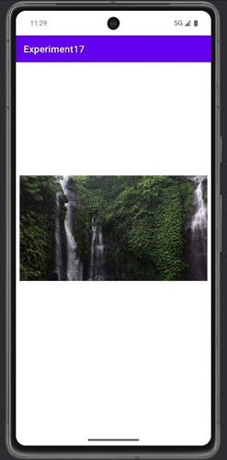

Practical No.18

Aim: Flutter Program based on Stateful and Stateless Widgets.

main.dart

import 'package:flutter/material.dart';

void main() {

runApp(MyApp());

}

// StatelessWidget: The root of the application

class MyApp extends StatelessWidget {

@override

Widget build(BuildContext context) {

return MaterialApp(

debugShowCheckedModeBanner: false,

title: 'Stateless vs Stateful Demo',

home: HomePage(),

);

}

}

// StatelessWidget: Represents the UI layout

class HomePage extends StatelessWidget {

@override

Widget build(BuildContext context) {

return Scaffold(

appBar: AppBar(

title: Text(

'Stateless & Stateful Widget',

style: TextStyle(fontWeight: FontWeight.bold, color: Colors.white),

),

backgroundColor: Colors.lightBlue,

),

body: Center(

child: CounterWidget(), // Our StatefulWidget

),

);

}

}

// StatefulWidget: Holds the state (e.g., counter)

class CounterWidget extends StatefulWidget {

@override

_CounterWidgetState createState() => _CounterWidgetState();

}

// The state class that changes over time

class _CounterWidgetState extends State<CounterWidget> {

int _counter = 0;

void _incrementCounter() {

setState(() {

_counter++; // Update the state

});

}

@override

Widget build(BuildContext context) {

return Column(

mainAxisAlignment: MainAxisAlignment.center,

children: [

Text('You have pressed the button this many times:'),

Text(

'$_counter',

style: TextStyle(fontSize: 30, fontWeight: FontWeight.bold),

),

SizedBox(height: 20),

ElevatedButton(

onPressed: _incrementCounter,

child: Text('Increment Counter'),

),

],

);

}

}

OUTPUT:

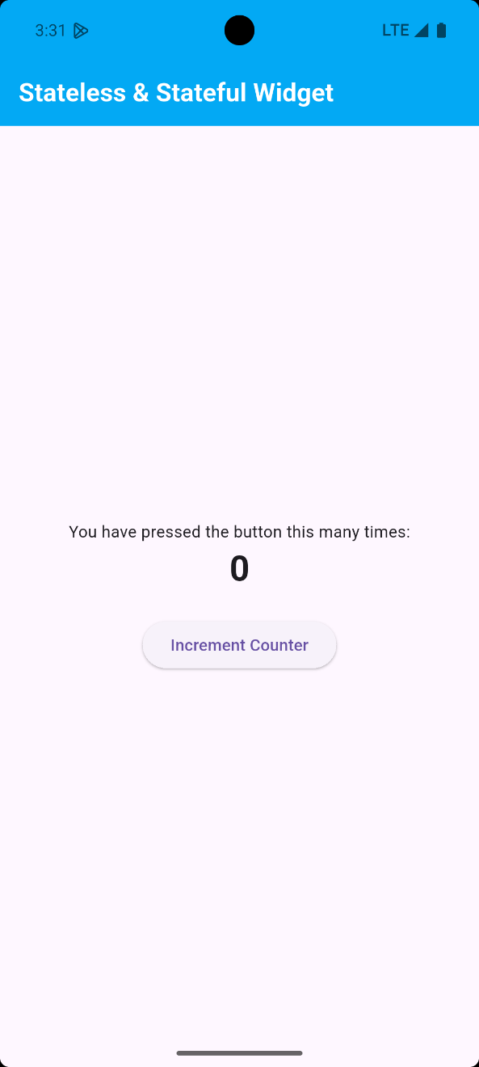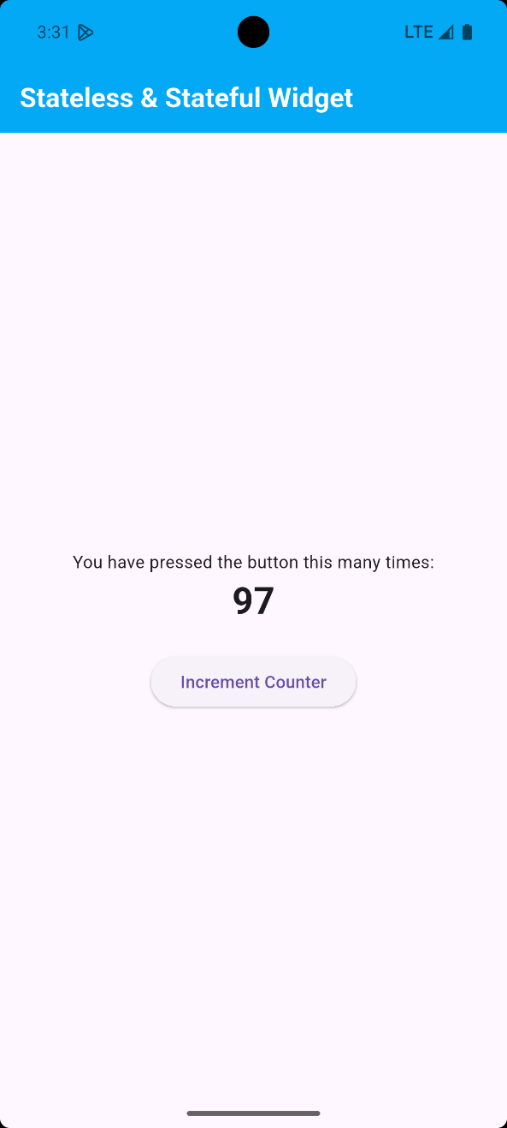

Practical No.19

Aim: Flutter Program using List

main.dart

import 'package:flutter/material.dart';

void main() {

runApp(MyApp());

}

class MyApp extends StatelessWidget {

@override

Widget build(BuildContext context) {

return MaterialApp(

debugShowCheckedModeBanner: false,

title: 'List Example',

theme: ThemeData(primarySwatch: Colors.green),

home: FruitListScreen(),

); }}

class FruitListScreen extends StatelessWidget {

final List<String> fruits = [

'Apple', 'Banana', 'Orange', 'Mango', 'Pineapple', 'Grapes', 'Strawberry', 'Watermelon', 'Papaya', 'Kiwi', ];

@override

Widget build(BuildContext context) {

return Scaffold(

appBar: AppBar(

title: Text(

'Flutter List',

style: TextStyle(fontWeight: FontWeight.bold, color: Colors.white),

),

backgroundColor: Colors.lightBlue,

),

body: ListView.builder(

itemCount: fruits.length,

itemBuilder: (context, index) {

return Card(

margin: EdgeInsets.symmetric(vertical: 6, horizontal: 12),

child: ListTile(

leading: CircleAvatar(child: Text(fruits[index][0])),

title: Text(fruits[index]),

trailing: Icon(Icons.arrow_forward_ios),

onTap: () {

ScaffoldMessenger.of(context).showSnackBar(

SnackBar(content: Text('You selected ${fruits[index]}')),

); }, ),); },),);}}

OUTPUT:

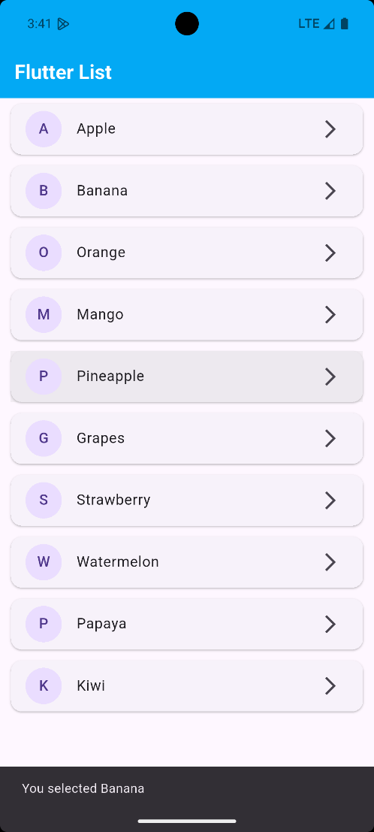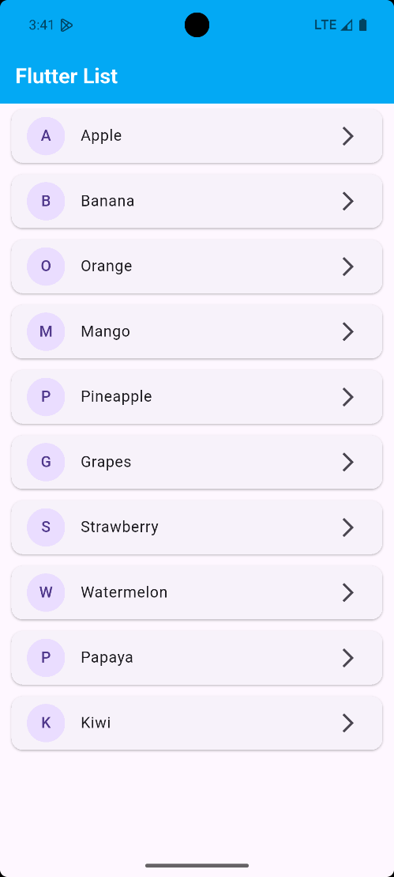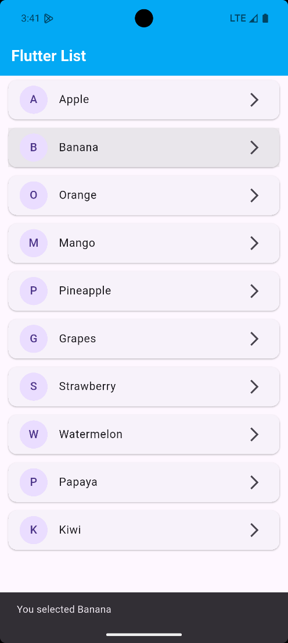

Practical No.20

Aim: Flutter Program using TextField, Check Box, Buttons, Drop down,

Switch etc.

main.dart

import 'package:flutter/material.dart';

void main() {

runApp(MyApp());

}

class MyApp extends StatelessWidget {

@override

Widget build(BuildContext context) {

return MaterialApp(

title: 'Flutter Form Example',

theme: ThemeData(primarySwatch: Colors.blue),

home: FormScreen(),

);

}

}

class FormScreen extends StatefulWidget {

@override

_FormScreenState createState() => _FormScreenState();

}

class _FormScreenState extends State<FormScreen> {

String name = '';

bool agreeToTerms = false;

bool notificationsEnabled = false;

String selectedGender = 'Male';

String result = '';

final TextEditingController nameController = TextEditingController();

final List<String> genderOptions = ['Male', 'Female', 'Other'];

void handleSubmit() {

setState(() {

name = nameController.text;

result =

'Name: $name\nGender: $selectedGender\nAgreed to Terms: ${agreeToTerms ? "Yes" : "No"}\nNotifications: ${notificationsEnabled ? "Enabled" : "Disabled"}';

});

}

@override

Widget build(BuildContext context) {

return Scaffold(

appBar: AppBar(

title: Text(

'User Info Form',

style: TextStyle(fontWeight: FontWeight.bold, color: Colors.white),

),

backgroundColor: Colors.lightBlue,

),

body: SingleChildScrollView(

padding: EdgeInsets.all(16.0),

child: Column(

crossAxisAlignment: CrossAxisAlignment.start,

children: [

TextField(

controller: nameController,

decoration: InputDecoration(

labelText: 'Enter your name',

border: OutlineInputBorder(),

),

),

SizedBox(height: 16),

DropdownButtonFormField<String>(

value: selectedGender,

items: genderOptions

.map(

(gender) =>

DropdownMenuItem(value: gender, child: Text(gender)),

)

.toList(),

onChanged: (value) {

setState(() {

selectedGender = value!;

});

},

decoration: InputDecoration(

labelText: 'Select Gender',

border: OutlineInputBorder(),

),

),

SizedBox(height: 16),

CheckboxListTile(

title: Text('I agree to the terms and conditions'),

value: agreeToTerms,

onChanged: (value) {

setState(() {

agreeToTerms = value!;

});

},

),

SwitchListTile(

title: Text('Enable Notifications'),

value: notificationsEnabled,

onChanged: (value) {

setState(() {

notificationsEnabled = value;

});

},

),

Center(

child: ElevatedButton(

onPressed: handleSubmit,

child: Text('Submit'),

),

),

SizedBox(height: 20),

if (result.isNotEmpty)

Text(

result,

style: TextStyle(fontSize: 16, fontWeight: FontWeight.bold),

),

],

),

),

);

}

}

OUTPUT:

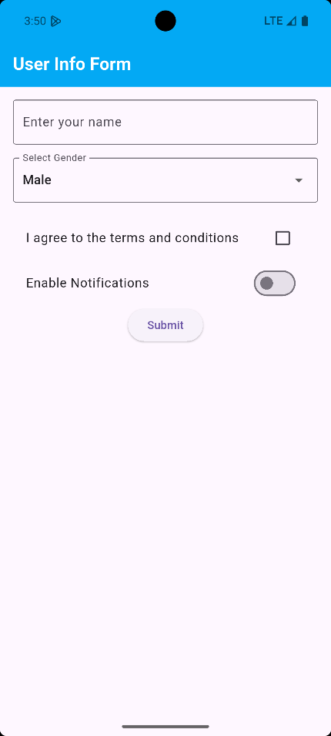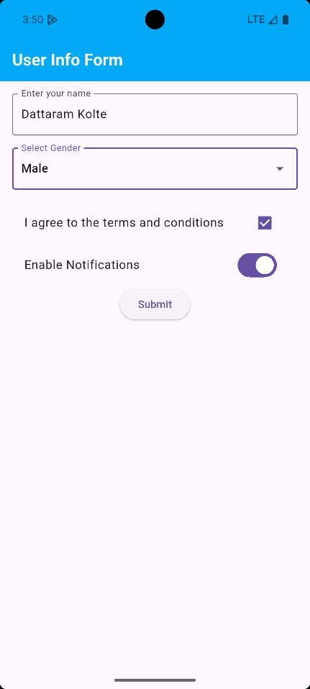

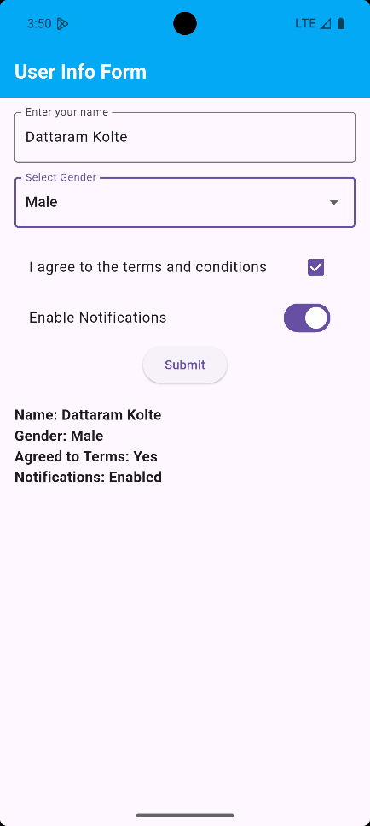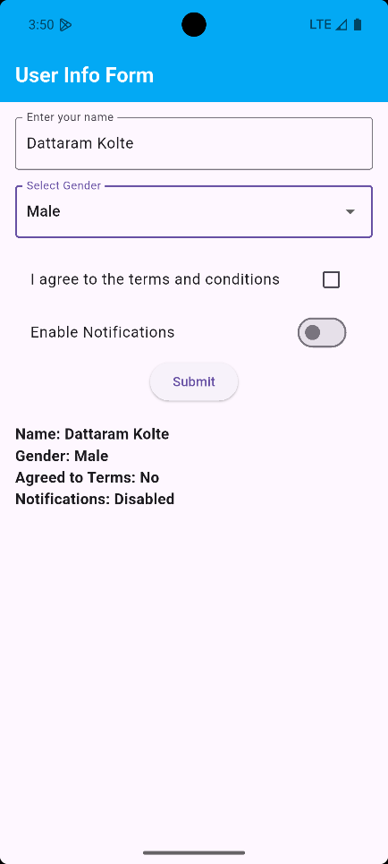

Practical No.21

Aim: Program to demonstrate the use of SQFlite Database using flutter

main.dart

import 'package:flutter/material.dart';

import 'database_helper.dart';

import 'user.dart';

void main() {

WidgetsFlutterBinding.ensureInitialized();

runApp(const MyApp());

}

class MyApp extends StatelessWidget {

const MyApp({super.key});

@override

Widget build(BuildContext context) {

return MaterialApp(

debugShowCheckedModeBanner: false,

title: 'Flutter SQFlite',

home: const UserListScreen(),

); }}

class UserListScreen extends StatefulWidget { const UserListScreen({super.key});

@override State<UserListScreen> createState() => _UserListScreenState();}

class _UserListScreenState extends State<UserListScreen> {

final DatabaseHelper _dbHelper = DatabaseHelper();

List<User> _users = [];

@override

void initState() {

super.initState();

_loadUsers(); }

Future<void> _loadUsers() async {

final users = await _dbHelper.getUsers();

setState(() {

_users = users; }); }

Future<void> _addUser() async {

final newUser = User(

name: 'New User ${DateTime.now().millisecond}',

age: 30, );

await _dbHelper.insertUser(newUser);

_loadUsers(); }

Future<void> _updateUser(User user) async {

final updatedUser = User(

id: user.id,

name: '${user.name} (Updated)',

age: user.age + 1, );

await _dbHelper.updateUser(updatedUser);

_loadUsers(); }

Future<void> _deleteUser(int id) async {

await _dbHelper.deleteUser(id);

_loadUsers(); }

@override

Widget build(BuildContext context) {

return Scaffold(

appBar: AppBar(

title: const Text('Flutter SQFlite User List'),

backgroundColor: Colors.lightBlue,

actions: [IconButton(icon: const Icon(Icons.add), onPressed: _addUser)], ),

body: ListView.builder(

itemCount: _users.length,

itemBuilder: (context, index) {

final user = _users[index];

return ListTile(

title: Text(user.name),

subtitle: Text('Age: ${user.age}'),

trailing: Row(

mainAxisSize: MainAxisSize.min,

children: [

IconButton(

icon: const Icon(Icons.edit),

onPressed: () => _updateUser(user),

),

IconButton(

icon: const Icon(Icons.delete),

onPressed: () => _deleteUser(user.id!),

), ], ), ); }, ), ); }}

user.dart

class User {

final int? id;

final String name;

final int age;

User({this.id, required this.name, required this.age});

Map<String, dynamic> toMap() {

return {'id': id, 'name': name, 'age': age};

}

factory User.fromMap(Map<String, dynamic> map) {

return User(id: map['id'], name: map['name'], age: map['age']);

}

@override

String toString() {

return 'User{id: $id, name: $name, age: $age}';

}}

database_helper.dart

import 'dart:async';

import 'package:path/path.dart';

import 'package:sqflite/sqflite.dart';

import 'user.dart'; // Import your User model

class DatabaseHelper {

static final DatabaseHelper _instance = DatabaseHelper._internal();

static Database? _database;

factory DatabaseHelper() {

return _instance;

}

DatabaseHelper._internal();

Future<Database> get database async {

if (_database != null) return _database!;

_database = await _initDatabase();

return _database!;

}

Future<Database> _initDatabase() async {

String path = join(await getDatabasesPath(), 'user_database.db');

return await openDatabase(

path,

version: 1,

onCreate: (db, version) {

return db.execute(

'CREATE TABLE users(id INTEGER PRIMARY KEY AUTOINCREMENT, name TEXT, age INTEGER)',

);

},

);

}

// Insert a user

Future<int> insertUser(User user) async {

final db = await database;

return await db.insert(

'users',

user.toMap(),

conflictAlgorithm: ConflictAlgorithm.replace,

);

}

// Retrieve all users

Future<List<User>> getUsers() async {

final db = await database;

final List<Map<String, dynamic>> maps = await db.query('users');

return List.generate(maps.length, (i) {

return User.fromMap(maps[i]);

});

}

// Update a user

Future<int> updateUser(User user) async {

final db = await database;

return await db.update(

'users',

user.toMap(),

where: 'id = ?',

whereArgs: [user.id],

);

}

// Delete a user

Future<int> deleteUser(int id) async {

final db = await database;

return await db.delete('users', where: 'id = ?', whereArgs: [id]);

}

}

OUTPUT:

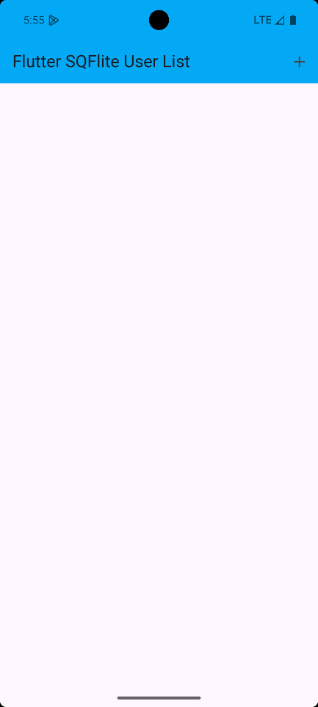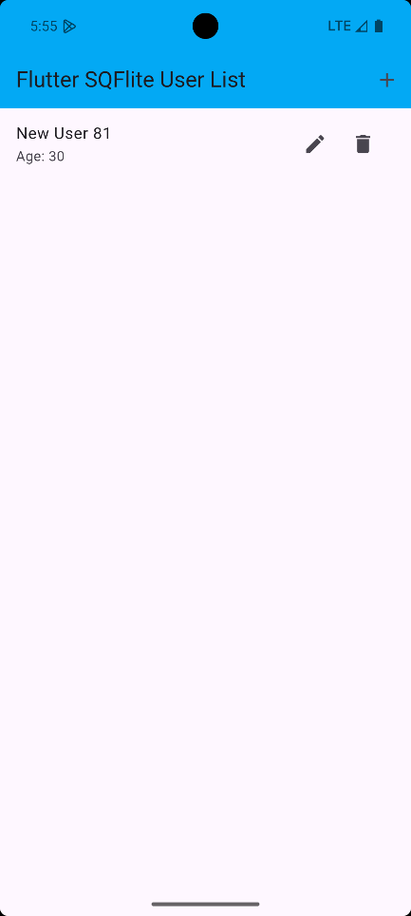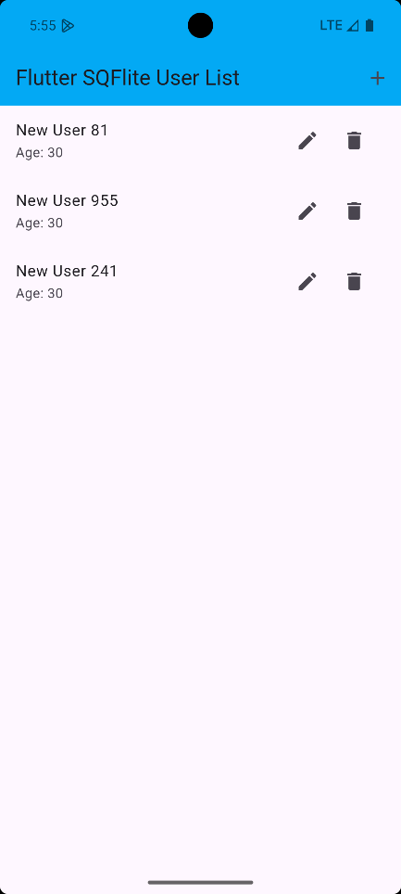

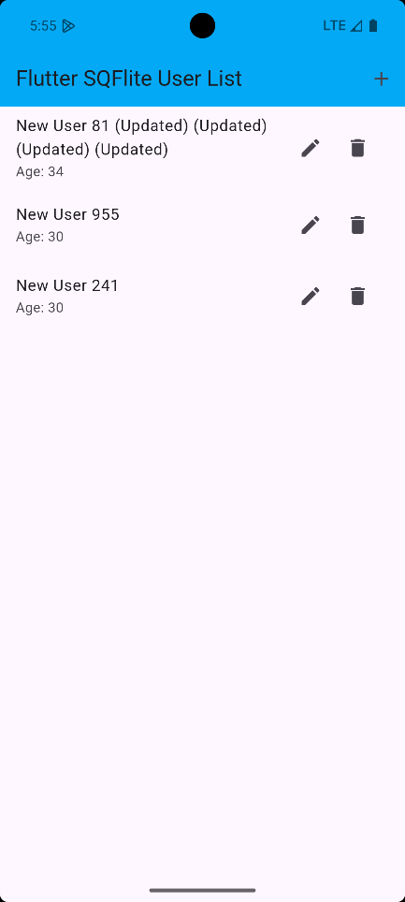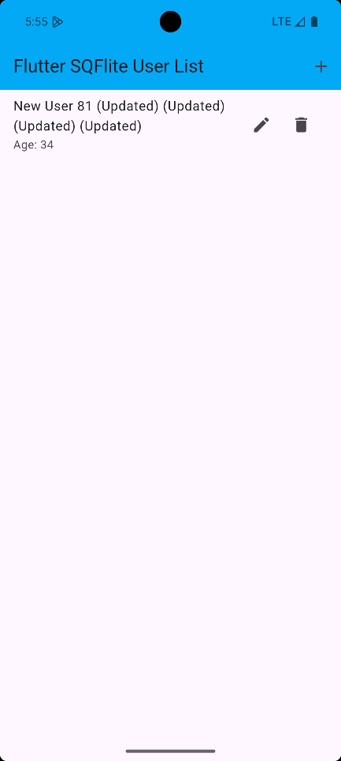

Practical No.22

Aim: Program to demonstrate the use of RESTAPI

main.dart

import 'package:flutter/material.dart';

import 'package:flutter_api/post.dart';

import 'package:flutter_api/post_service.dart';

void main() {

runApp(const MyApp());

}

class MyApp extends StatelessWidget {

const MyApp({super.key});

@override

Widget build(BuildContext context) {

return MaterialApp(

title: 'Flutter REST API',

theme: ThemeData(primarySwatch: Colors.blue),

home: const PostsPage(),

); }}

class PostsPage extends StatefulWidget {

const PostsPage({super.key});

@override

State<PostsPage> createState() => _PostsPageState();}

class _PostsPageState extends State<PostsPage> {

late Future<List<Post>> futurePosts;

@override

void initState() {

super.initState();

futurePosts = fetchPosts(); }

@override

Widget build(BuildContext context) {

return Scaffold(

appBar: AppBar(title: const Text('Posts')),

body: FutureBuilder<List<Post>>(

future: futurePosts,

builder: (context, snapshot) {

if (snapshot.connectionState == ConnectionState.waiting) {

return const Center(child: CircularProgressIndicator());

} else if (snapshot.hasError) {

return Center(child: Text('Error: ${snapshot.error}'));

} else if (!snapshot.hasData || snapshot.data!.isEmpty) {

return const Center(child: Text('No posts found'));

} else {

final posts = snapshot.data!;

return ListView.builder(

itemCount: posts.length,

itemBuilder: (context, index) {

final post = posts[index];

return ListTile(

title: Text(post.title),

subtitle: Text(post.body),

); }, ); } }, ), ); }}

post.dart

class Post {

final int userId;

final int id;

final String title;

final String body;

Post({

required this.userId,

required this.id,

required this.title,

required this.body, });

factory Post.fromJson(Map<String, dynamic> json) {

return Post(

userId: json['userId'],

id: json['id'],

title: json['title'],

body: json['body'],

); }}

post_services.dart

import 'dart:convert';

import 'package:flutter_api/post.dart';

import 'package:http/http.dart' as http;

Future<List<Post>> fetchPosts() async {

try {

print('Fetching posts from API...');

final response = await http

.get(

Uri.parse('https://jsonplaceholder.typicode.com/posts'),

headers: {'Content-Type': 'application/json'}, )

.timeout(Duration(seconds: 10));

print('Response status code: ${response.statusCode}');

print('Response body length: ${response.body.length}');

if (response.statusCode == 200) {

final List<dynamic> jsonData = json.decode(response.body);

print('Successfully parsed ${jsonData.length} posts');

return jsonData.map((item) => Post.fromJson(item)).toList();

} else {

throw Exception(

'Failed to load posts. Status code: ${response.statusCode}, Body: ${response.body}',

); } } catch (e) {

print('Error in fetchPosts: $e');

throw Exception('Failed to load posts: $e');

}}

OUTPUT:

